Energy Emergency Response Playbook
for States and Territories
May 2022

This resource was produced by the U.S. Department of Energy’s Office of Cybersecurity, Energy Security, and Emergency Response (CESER) to aid states in energy emergency planning. States may choose to incorporate parts or all of the provided material (optional) in their State Energy Security Plans (SESPs). States are encouraged to adapt or supplement the provided material to align with existing state roles, authorities, and plans; and to better address state-specific needs and situations.

Acknowledgement
The Energy Emergency Response Playbook for States and Territories was developed through the partnership with U.S. Department of Energy’s (DOE) Office of Cybersecurity, Energy, Security, and Emergency Response (CESER) and the National Association of State Energy Officials (NASEO). Brandi Martin (DOE CESER) led the development of the Playbook with support from Campbell Delahoyde (NASEO), and Kirsten Verclas (NASEO).

The Playbook was authored by ICF including Kevin DeCorla-Souza, Matt Kelly, Jennifer Matthews, Anne Ressler, and Jason Pazirandeh. Review and comments were provided by emergency response officials at DOE CESER, including Kate Marks, Ken Buell, Christian Cando, and Bill Eaton; and NASEO staff. Converge Strategies, LLC also contributed to the playbook.

The authors also thank the following state and territorial energy officials and public utility commissioners for their contributions, review, and comments to inform the contents of this playbook:
- Ben Bolton, Tennessee Department of Environment and Conservation
- Megan Levy, Wisconsin Office of Energy Innovation
- Paul Holloway, Massachusetts Department of Energy Resources
- Edward O’Brien, Louisiana Department of Natura Resources
- Matt Milford, New York State Energy Research and Development Agency
- Joe Osso, New York State Energy Research and Development Agency
- Deanna Henry, Oregon Department of Energy
- Amanda Eyer, Pennsylvania Department of Environmental Protection
- JB Cuartas, New Jersey Board of Public Utilities
- Carlos Tejera Fernandez, Puerto Rico Department of Economic Development and Commerce

Disclaimer

This material is based upon work supported by the Department of Energy. It was prepared as an account of work sponsored by an agency of the United States Government. Neither the United States Government nor any agency thereof, nor any of their employees, makes any warranty, express or implied, or assumes any legal liability or responsibility for the accuracy, completeness, or usefulness of any information, apparatus, product, or process disclosed, or represents that its use would not infringe privately owned rights. Reference herein to any specific commercial product, process, or service by trade name, trademark, manufacturer, or otherwise does not necessarily constitute or imply its endorsement, recommendation, or favoring by the United States Government or any agency thereof. The views and opinions of authors expressed herein do not necessarily state or reflect those of the United States Government or any agency thereof.

Introduction
The Energy Emergency Response Playbook for States and Territories provides State Energy Offices with preparing for, responding to, and recovering from energy emergencies. The Playbook is intended to complement (but not replace) State Energy Security Plans (SESPs) by providing guidance on how and when to utilize authorities and response actions detailed in SESPs. This Playbook presumes that SESPs are in place and that state emergency response roles and responsibilities are defined and understood.
This Playbook provides a starting point for energy emergency response planning, including a framework for evaluating energy emergencies, guidance and templates for emergency response actions, and other supplemental planning, monitoring, and response resources. This Playbook is not intended to be prescriptive or suggest non-statutory expansion of State Energy Office responsibilities or purview during energy emergencies. Responsibilities may vary significantly from state to state.
Playbook users (state and territorial energy officials) are encouraged to add to, edit, and expand this Playbook to include additional state-specific actions, resources, and responsibilities. Users are encouraged to make structural edits that best meet their unique needs or to best integrate with existing plans, policies, and procedures. After customizing this Playbook to fit state-specific structures and authorities, states may incorporate the Playbook as part of their SESPs.

Playbook Structure
Emergency management is a continuous cycle of Preparedness → Response → Recovery → Mitigation. This Playbook focuses on the Response part of the cycle. Responding to energy emergencies involves an iterative process of gathering information, assessing the actual or potential consequences of the incident, and taking action to share critical information, facilitate system restoration, and mitigate impacts to dependent lifeline sectors and consumers. This process is repeated over the course of an emergency with response actions adapting to changing conditions as the situation evolves.
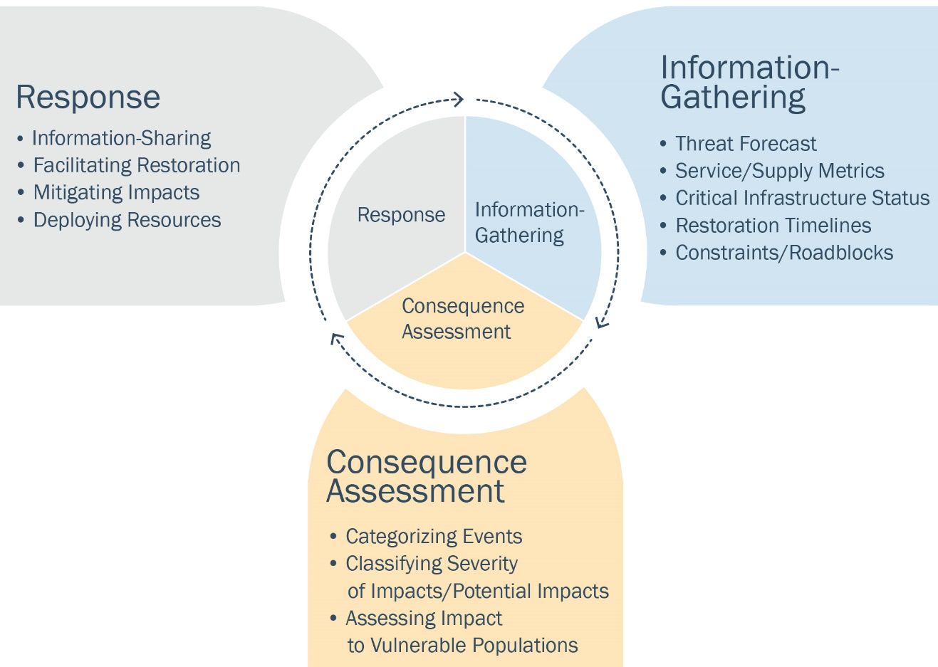

This Playbook is arranged into three sections that align with the three stages of the Response Cycle. Each section provides guidance and resources that are tailored to emergencies involving power, liquid fuel, and natural gas systems. Supplemental information is provided in the appendices.

The Playbook includes:
Information-Gathering/Situational Awareness provides a list of informational resources for monitoring energy supply, inventories, and markets, as well as weather-related threats……………………………………………………………………………………………………… (page 5)
Consequence Assessment provides guidance for categorizing and assessing the consequence of an event to inform a proportional response……………….…..…. (page 10)
Response Actions identifies response measures by the event type, actor, event consequence, and the time phase of the emergency event………………………… (page 15)

The Playbook includes appendices with supplemental information for emergency response planning:
Appendix A: Situational Awareness Tools describes resources identified in the Information Gathering/Situational Awareness chapter, including descriptions of each tool and examples of how these tools can be used to monitor energy markets and inform response activities…………………………………………………………………….…… (page 33)
Appendix B: Information-Sharing Contact List provides a template for creating a list of key energy emergency response contacts………………………………………………….. (page 47)
Appendix C: Threats and Potential Impacts to Energy provides a list of threats and their associated potential impacts to energy systems…………………………………..….… (page 51)
Appendix D: Supply Chain Diagrams provides flow diagrams that summarize the electricity, natural gas, liquid fuels, and propane supply chains………………….. (page 53)
Appendix E: Interdependency Diagrams summarize the interdependencies within the energy sector and between the energy sector and other lifeline sectors……… (page 59)
Appendix F: Considerations for Territories and Remote Areas outlines challenges and considerations for remote locations during energy emergencies…………..…….. (page 63)
Appendix G: Considerations for Vulnerable Populations provides considerations for vulnerable populations during energy emergencies…………………………….……… (page 64)
Appendix H: Acronyms provides a list of acronyms used in the Playbook………. (page 67)

It’s a good practice to continually update this playbook in line with your specific, evolving needs. Once completed, use this table to record the date of your most recent update and the staff member responsible.
TO DO:
Edit the Playbook to reflect your state’s response measures.
- Information-Gathering/Situational Awareness: Add additional resources utilized during energy emergencies. Add company information and note who the information is to be shared with.
- Consequence Assessment: Edit the consequence scale to align with your state’s response framework. Add example events appropriate for your state or region.
- Response: Edit the response matrices to reflect the unique structure of your state’s emergency response activities. Use the additional space to add content as needed or delete activities that do not apply.

Date of Update | Staff Member Responsible for Update | Email

Information-Gathering/Situational Awareness
The first stage in emergency response is to gather timely, accurate, and actionable information on threats and impacts to energy systems and services. This information provides the situational awareness needed to inform subsequent steps in the response process (consequence assessment and response actions). The following table lists situational awareness resources by energy type and indicates the type of information available. The resources in this table are linked to Appendix A: Situational Awareness Tools State which describes each resource and provides a hyperlink to the resource. Responders can add state-specific resources and their role by sector to this table and then supplement it with additional information in Appendix A.

Situational Awareness Tools
Key: Data type
Geospatial | Inventory | Production/ Generation | Transport/ Transmission/ Distribution | Consumer Outages | Pricing

Tool | Power | Liquid Fuels | Natural Gas
U.S. Department of Energy (DOE) Tools
DOE Emergency Situation Reports | Customer outages and summaries of electric system damage and estimate restoration timelines. Level of resources committed for restoration | Refinery status, capacity, and output, petroleum terminal status, regional product inventories, offshore crude oil production impacts | Natural gas pipeline status, gas utility customer outages, onshore and offshore natural gas production impacts
DOE EAGLE-I | Power outages by utility and by county in near real time | Refinery process unit status alerts | Natural gas pipelines critical notices
DOE Estimated Customer Power Outages | Predicted customer outages based on strength and track of hurricane or major storms | Can be used to identify the critical petroleum infrastructure that may be impacted by the storm or by power outages | Predict the degree that electrically powered compressors, if used, may be affected

U.S. Energy Information Administration (EIA) Tools
EIA Energy Atlas | Electricity infrastructure: power plants, substations, transmission lines, electric retail service territories | Liquid fuels infrastructure: oil wells, platforms, pipelines, biofuel plants, terminals, refineries (locations and capacities) | Natural gas infrastructure: gas wells and platforms, pipelines, natural gas processing plants, underground storage
EIA Hourly Grid Monitor | Hourly electricity generation by fuel type, interchange, and day-ahead demand forecasts | Hourly oil-fired generation | Hourly natural gas-fired generation
EIA Weekly Petroleum Status Report | - | Weekly supply, demand, inventory, and import data | -
EIA Winter Heating Fuels | Electric generation and prices | Propane and heating oil inventories and prices | Natural gas inventories and gas prices
EIA SHOPP | - | State weekly residential heating oil and propane prices | -
EIA Natural Gas Storage Dashboard | - | - | Evaluate natural gas storage activity, consumption by sector, exports, and prices
EIA Daily Prices | Daily electricity prices | Daily crude, gasoline, diesel, and propane prices | Daily natural gas spot prices
Other Government Agency Tools
U.S. Coast Guard Homeport | - | Operational status of ports that import/export oil | Operational status of ports that import/export liquified natural gas (LNG)
NPMS PIMMA | - | Crude oil and petroleum product pipeline locations | Natural gas pipeline and LNG plant locations
BSEE Activity Statistics Update | - | Oil production shut-in and rig activity | Natural gas production shut-in and rig activity
HHS emPOWER Map | Locations of electricity-dependent individuals with medical needs | - | -

Industry/Public Tools
GasBuddy | Power outages at gas stations | Gas station operational status (without fuel or without power) and real time retail prices | -
Company Websites/  Social Media | Estimated restoration timelines | Updates on infrastructure status, usually via press releases | Critical notices on natural gas company websites, daily gas flows to delivery points
RTO/ISO Websites  RTO ISO Locational Marginal Pricing | Power grid operational alerts, current and projected supply and demand, and locational marginal pricing | - | -
Trade Press | Customer outages for small utilities and estimated restoration times | Refinery, pipeline, and terminals status updates | Natural gas pipeline and LNG terminal status updates
Tool | Power | Liquid Fuels | Natural Gas
State-Specific Tools

State officials should also monitor weather forecasts to understand the potential impacts on energy supply, demand, and infrastructure. The table below lists several key tools for monitoring weather-related threats. States should customize this list for their region, as appropriate.

Weather Threat Monitoring Tools
Threat Forecasts | Description | Frequency of Updates
NOAA’s National Weather Service | Weather warnings, watches, alerts, and advisories across the United States. | Every five minutes
NOAA 6- to 10-Day Outlook | Weather and precipitation forecast confidence intervals across the United States looking out 6 to 10 days. | Daily
National Hurricane Center Tropical Weather Outlook | Identifies hurricanes, tropical storms, and tropical disturbances and their potential for development over the next five days. | Approximately 2:00 a.m., 8:00 a.m., 2:00 p.m., and 8:00 p.m. ET from  May 15 to Nov. 30
EIA Energy Atlas Disruptions | Weather threats (e.g., hurricanes, wildfires, flooding) mapped against selected energy infrastructure. | Layers vary
DOE EAGLE-I Mapper | Weather threats (e.g., hurricanes, wildfires, flooding, drought, earthquakes) mapped against selected energy infrastructure and/or state- or county-level electric customer outages. | Layers vary
NASA and USDA’s Fire Information Resource Management System | Identify the location, extent, and intensity of wildfire activity using satellite monitoring. | Twice per day
NOAA’s River Observations and Forecasts | Identifies current and forecast water levels at river gauges across the United States. | Every five minutes

Industry, Peer, and Regional Outreach

In addition to the data tools identified above, State Energy Offices should gather information prior to and during energy emergencies by leveraging relationships with industry contacts, industry trade organizations, other state agencies, the federal government, and energy offices in other states. The Energy Emergency Assurance Coordinators Program is a primary source of state contacts, which can be found on the ISERnet. These contacts should be identified and developed in advance of an emergency. Through this outreach, State Energy Offices can learn about energy infrastructure and market impacts that may not be available via monitoring tools.
NASEO and DOE CESER host calls leading up to and during large events to provide share and collect information. Appendix B: Information-Sharing Contact List provides a template for state and local officials to catalog key contacts for quick reference during energy emergencies.
If a State Energy Office is having challenges identifying, contacting, or receiving responses from energy industry contacts, officials can contact NASEO or their ESF-12 regional coordinator to request assistance.

Consequence Assessment
Throughout the course of an energy emergency, state energy and emergency response officials should continually evaluate the consequences to inform the magnitude, duration, and geographic extent of required response actions. This involves assessing quantitative and qualitative data collected during the information-gathering/situational awareness stage.
Consequence assessments during response build on pre-event or “blue sky” day baselining activities. Baselining activities include developing state energy profiles that identify key energy infrastructure and standard volumes of energy supply and demand, as well as understanding typical market dynamics, energy prices, and other metrics to be used as a point of comparison during emergency events.
Information to consider during the consequence assessment includes but is not limited to:
- Threat information, including an assessment of how different types of threats impact energy systems. Appendix C: Threats and Potential Impacts to Energy provides a high-level summary of common threats and impacts.
- Impacts to energy consumers (e.g., customer power outages, retail gas station outages), including their magnitude and anticipated duration of impacts (i.e., restoration timelines).
- Impacts to lifeline sectors. The FEMA Community Lifelines (e.g., safety and security, health and medical, transportation) are fundamental community services. Lifelines enable all other aspects of society to function, and there are often interdependencies between lifeline sectors. Energy restoration to lifeline sectors is typically prioritized during response both to facilitate additional energy restoration and to stabilize broader community services. Appendix E: Interdependency Diagram outlines lifeline interdependencies.
- Impacts to vulnerable populations, who are disproportionately affected by energy disruptions. Vulnerable communities may require more assistance to navigate energy events, including additional resources (e.g., backup generators, heating and cooling centers) and targeted outreach. Appendix G: Considerations for Vulnerable Populations outlines how different vulnerable populations may be impacted during an energy emergency.
- Impacts to critical energy delivery systems (e.g., critical power plants, pipelines, refineries), including an assessment of the impacts on supply chains and the availability of alternative supply options. The diagrams in Appendix D provides an overview of how various energy supply chains work.
- Impacts to bulk/wholesale energy markets (e.g., bulk fuel stocks, electric balancing authority reserve margins), including impacts on prices.
State Energy Offices should consider the above factors and other available information when assessing the consequences of an energy emergency. While there are many frameworks for assessing consequences, this Playbook utilizes a tiered approach that generally aligns with the National Incident Management Systems (NIMS) Incident Complexity Guide and DOE’s response activation guidance. Like the NIMS event types, this Playbook’s tiers use an inverted scale, with lower numbers indicating greater event consequences. Tiers 3, 2, and 1 generally correspond to NIMS Types 3, 2, and 1. NIMS event Types 4 and 5 are generally assumed to be energy events requiring minimal involvement from State Energy Offices and thus are not addressed in this Playbook.
- Tier 3: Enhanced Watch events are characterized by impacts to energy supply chains and/or energy services that are largely remediated by industry with little to no need for support from the state or federal governments. State Energy Offices should enhance situational monitoring to understand if and when greater response actions are needed.
- Tier 2: Significant Events are significant disruptions to energy supply chains and/or energy services with longer timelines for restoration. Response to these events typically exceed local government resources. Industry will also typically seek state government assistance in the form of waivers and resource management to expedite restoration of energy infrastructure or to mitigate impacts on affected populations or lifeline sectors.
- Tier 1: Major Events are characterized by extensive disruption to energy supply chains and/or energy services with extended or indefinite timelines for restoration. Tier 1 events require a massive response at every level of government to assist and expedite restoration and to mitigate the impact on affected populations and lifeline sectors.
Consequence indicators and examples of recent emergencies for each tier are presented on the following pages. State Energy Offices may add examples of state emergencies, adding relevant and recent state events. Some states may employ other consequence frameworks, and state officials should customize this Playbook to align with their specific structures.
Consequence assessment is an ongoing activity throughout an incident. For events with advance notice, such as hurricanes, the potential consequences of an event may be assessed using forecasts and any available predictive outage or impact-modeling tools. In the immediate aftermath of an event, damage and impact assessments may take time to conduct, and state officials may need to take action based on incomplete or imperfect information. During the restoration period, consequences should be continually reassessed as operators repair critical energy infrastructure and restore energy services to end users.
During an emergency event, consequences may also vary by energy type. A disruption to a key liquid fuels pipeline, for example, may rate as a Tier 2 event for liquid fuels but may not rate on the scale for electric power or natural gas. The consequence tiers for each energy type relate directly to the response action matrices in the next section.

Power Outage/Electricity Shortage Event
Electricity emergencies generally fall into two categories: (1) service disruptions caused by damage to the transmission and distribution (T&D) grid (e.g., from adverse weather events), or (2) electricity supply shortages due to generation or transmission outages during periods of high demand, which can result in rolling blackouts or grid collapse if not properly managed. Electric utilities are generally well-equipped to deal with common T&D-level outages through internal resources and mutual-aid agreements with other utilities.
Tier | Consequences Indicators | Examples
Tier 3: Enhanced Watch | - Service Disruption: Localized power outages with short (less than 48 hours) restoration timelines  - Restoration work largely involves repairing fallen or damaged distribution lines and poles.  - Lifeline sectors largely maintained with backup generators. | - Common thunderstorms  - Common winter and ice storms  - Public Safety Power Shutoffs (PSPS) to prevent wildfires
 | - Electricity Shortage: Imbalance between supply and demand and elevated prices in some load areas. Grid operators issue lower-level communications (e.g., operating condition notices, conservation alerts, control room advisories) | - Heat waves or cold snaps that drive high electricity demands
Tier 2: Significant Event | - Service Disruption: Widespread power outages with longer (more than 48 hours) restoration timelines.  - Restoration work involves repairing damaged utility wires and structures across T&D systems.  - Lifeline sectors experience temporary or intermittent disruptions as backup generator fuel is exhausted and awaits replenishment.  - Vulnerable groups that rely on electricity moved to shelters or provided backup generators as needed. | - Hurricane Dorian (2019)  - Puerto Rico Magnitude 6.4 earthquake (2020)  - Dixie Fire in California (2021)
 | - Electricity Shortage: Grid operators issue emergency alerts for critical conservation and to maximize generation and transmission resource availability. Sharp price spikes across balancing areas. | - California drought and hydroelectric shortfall (2021)
Tier 1: Major Event | - Service Disruption: Widespread power outages with extended or indefinite restoration timelines (a week or longer).  - Extensive damage to T&D systems, including damage to substations and other system components that require longer repairs.  - Lifeline sectors, including Emergency Response, experience severe impacts from difficulty refueling vehicles and backup generators due to impact of power outages on liquid fuels supply chains. | - Hurricane Sandy (2012)  - Hurricane Maria (2017)  - Hurricane Laura (2020)  - Hurricane Ida (2021)
 | - Electricity Shortage: Grid operators initiate rolling blackouts to preserve grid stability. Typically associated with large-scale loss of generation resources due to power plant operational outages or power plant fuel shortages. | - Texas extreme cold weather event (2021)

Liquid Fuels Shortage Event
Shortages of liquid fuels (e.g., gasoline, distillate fuel oil, jet fuel, propane) can be caused by sudden surges in fuel demands and/or by significant disruptions along the fuel supply chain. Demand-driven shortages may develop for gasoline during pre-hurricane evacuations and for heating fuels (distillate fuel oil and propane) during periods of prolonged cold weather. Supply-driven shortages can be caused by disruptions to crude oil production, oil refining, and/or refined fuel transportation and distribution. Severe shortages often involve both demand- and supply-driven factors. Fuel shortage and fuel accessibility issues may also occur during extended power outages when power-dependent fuel infrastructure (e.g., terminals, pumps, refineries) are rendered inoperable and when there may be a simultaneous spike in fuel demand for backup generators and emergency response vehicles. Because liquid fuel is stored at every level of the supply chain—from bulk terminals to vehicle tanks—it typically takes several days for supply chain disruptions to cascade into widespread end user shortages, although panic buying can expedite the effects.
Tier | Consequence Indicators | Examples
Tier 3: Enhanced Watch | - Sporadic fuel outages and delivery delays impacting end users (e.g., gas stations, heating customers) as supply and distribution infrastructure struggles to keep up with sudden spike in demands.  - Localized supply shortages at bulk terminals. Distributors begin loading trucks at terminals further away to meet customer needs.  - Local or regional fuel inventories fall near or below the bottom of previous five-year range.  - Elevated price spreads versus U.S. benchmarks may indicate local or regional issues. | - Localized shortages for heating oil and propane in the Midwest and Northeast during the winter months
Tier 2: Significant Event | - Widespread run-outs and/or delivery delays for end users over a period of several days to weeks.  - Widespread supply shortages at bulk terminals as suppliers cannot meet all demands. Typically associated with extended outage of one or more critical supply assets.  - Sharp declines in local or regional fuel inventories to well below previous five-year lows.  - Sharp price spreads versus U.S. or international benchmarks may indicate significant regional issues. | - Midwest propane shortage (2014)  - Hurricane Irma evacuation (2017)  - Colonial Pipeline cyberattack (2021)
Tier 1: Major Event | - Fuel unavailable or inaccessible to most end users as widespread power outage or other common event renders retail outlets and critical supply infrastructure inoperable.  - Lifeline sectors, including Emergency Response, have difficulty finding supply, impacting provision of essential services.  - Vulnerable groups that rely on propane/heating oil moved to shelters. | - Hurricane Sandy (2012)  - Hurricane Maria (2017)

Natural Gas Shortage Event
Natural gas supply chains have significant redundancy and excess capacity during most of the year, and shortage events typically only occur during prolonged periods of high demand (e.g., extreme cold weather events) when natural gas transportation infrastructure is fully utilized. However, natural gas demand has grown significantly in recent years due to increased demand from the power sector. Pipeline infrastructure has been unable to keep pace with demand increases in some regions, which increases the potential for shortage events during peak periods. Due to the greater dependence on natural gas for power generation, gas shortages are more likely to have cascading effects on bulk electric system reliability.
Tier | Consequence Indicators | Examples
Tier 3: Enhanced Watch | - Major transmission pipeline issues Operational Flow Orders (OFOs) to avoid system strain. Usually driven by high-demand cold periods or infrastructure outages or constraints.  - High local or regional prices versus U.S. benchmarks may indicate issues.  - High prices in affected markets lead to voluntary fuel switching for power sector and industrial customers with the ability to switch. | - Periods of winter peak demand in pipeline-constrained New England
Tier 2: Significant Event | - A major transmission pipeline has an extended unplanned outage during a peak demand period.  - Some gas is rerouted into the region on alternate pipelines, but due to capacity constraints, supply is interrupted to power plants and other customers with non-firm contracts.  - Local distribution companies (LDCs) urge customers to conserve gas use.  - Gas supply disruptions to power generators reduce available generation resources, forcing grid operators to issue emergency advisories or alerts.  - Sharp spikes in local or regional prices versus U.S. benchmarks may indicate significant regional issues. | - Bomb cyclone impacting New England (2018)
Tier 1: Major Event | - Severe outage/damage or supply shortage forces transmission pipelines and LDCs to interrupt supply to firm customers.  - Loss of pressure in the gas distribution system causing gas to be shut off to firm customers (residential and commercial)  - Restoring service is time-consuming, as the LDC must relight each customer’s pilot light.  - Vulnerable groups that rely on gas heating moved to shelters.  - Loss of gas-fired generation leads to severe regional electricity shortages. Grid operators initiate rolling blackouts to preserve grid stability. | - Texas extreme cold weather event (2021)

Response Actions
Various energy sector stakeholders must take action throughout the course of an energy emergency to facilitate restoration of energy systems and to mitigate the impact of energy disruptions to critical infrastructure, essential services, and vulnerable populations. As part of this response, representatives from the State Energy Office may be activated to staff the State Emergency Operations Center (SEOC) during Tier 2 and Tier 3 events. This section outlines possible energy emergency response actions of various state and private sector actors. These actions are categorized by:
- Event Type: Power outages/electricity shortages, liquid fuel shortages, and natural gas shortages.
- Actor: State ESF-12 responders (often from the State Energy Office and Public Utilities Commission), emergency management, other state agencies, and industry.
- Event Consequence: Tiers 3, 2, and 1.
- Time-Phase of the Event
  - Pre-Event: The hours or days immediately preceding an anticipated event, such as a hurricane or major winter storm, when stakeholders may have ability to mobilize and prepare for eventual response action. Some “no-notice” events, such as a sudden infrastructure failure, will not have a pre-event component.
  - Response/Restoration: This period includes begins when impacts from the event (e.g., outage, shortage) are first felt until the time all impacts have been resolved.
The 12 matrices on the following pages provide a possible response options —categorized by time-phase and consequence tier—for each event type and actor. The links below can be used to jump to appropriate matrix. Note: the activities in each tier build on each other, so the response actions during a Tier 1 event would also be taken during Tier 2 and Tier 3 events.
Power Outage/  Electricity Shortage | Liquid Fuels Shortage | Natural Gas Shortage
State ESF-12  Emergency Management  Other State Government  Utilities and Grid Operators | State ESF-12  Emergency Management  Other State Government  Liquid Fuel Industry | State ESF-12  Emergency Management  Other State Government  Natural Gas Industry
These response matrices provide a starting point for response planning. Authorities, roles, responsibilities, and statutes vary widely by state. State officials should adapt these resources to align with their stakeholders’ roles within their states. Actions performed by State Energy Offices and other stakeholders may be a subset of the activities listed or include additional activities beyond those listed in the Playbook. Response options for stakeholders other than State Energy Offices are included for awareness and are not intended to be prescriptive or comprehensive.
TO DO:
Review and edit the following ESF-12 matrices to reflect your office’s responsibilities, authorities, and informal activities. The matrices provide examples of common activities, but content should be deleted and expanded upon as needed to reflect your state’s unique role. Blank lines in each matrix provide space to add content as needed.
Update response matrices following disruptive events: Consider past events in your state and lessons learned to update appropriate actions.
Work with stakeholders (as applicable: additional ESF-12 agencies, emergency management agencies, other state government agencies, utilities, and grid operators) to understand their roles, authorities, and informal activities. Use the example activities listed in the following matrices as the basis for discussion and edit the matrices’ content as needed based on stakeholders’ feedback.

ESF-12: State Energy Office, Public Utilities Commission

 | Pre-Event | Response
Tier 3: Enhanced Watch | - Situational Awareness and Information-Sharing: Monitor threat forecasts and predictive outage modeling  - Situational Awareness and Information-Sharing: Identify risk factors that could exacerbate or prolong energy impacts or cause impacts to cascade into other sectors  - Situational Awareness and Information-Sharing: Report outages or other operational issues to DOE as required  - Situational Awareness and Information-Sharing: Understand current demand for electricity within the state, including use by critical users, and how demand may change during event  - _______________________________________________________  - _______________________________________________________ | - Situational Awareness and Information-Sharing: Leverage monitoring tools and stakeholder contacts to gather information on outage impacts and duration  - Situational Awareness and Information-Sharing: Identify cascading impacts or interdependencies, including potential impacts to petroleum and natural gas systems  - Situational Awareness and Information-Sharing: For cyber events, engage with the MS-ISAC to receive information about the incident and any additional cyber threats  - Situational Awareness and Information-Sharing: For cyber events, coordinate with state Chief Information Officer or other state cyber office on messaging, response, and whether there are any threats to state systems  - Resource Management: Assess staffing capabilities and resource adequacy of state to respond to the event  - __________________________________________________________________
Tier 2: Significant Event | - Situational Awareness and Information-Sharing: Participate in internal and external situational awareness activities (e.g., regional calls, federal calls, briefing state leadership, etc.)  - Situational Awareness and Information-Sharing: Communicate information on predicted power outages to state ESF-12 stakeholders  - Resource Management: Coordinate with emergency managers to inventory available state resources (e.g., generators, etc.) and identify any resource shortages or limitations that could affect event response  - Situational Awareness and Information-Sharing: For pre-event evacuations, monitor the status of electric vehicle charging station status along evacuation routes  - ___________________________________________________  - ___________________________________________________ | - Situational Awareness and Information-Sharing: Develop situation reports and share with stakeholders, including information on the extent and duration of power outages  - Situational Awareness and Information-Sharing: Participate in internal and external situational awareness activities (e.g., state calls, regional calls, federal calls, state leadership briefs, etc.)  - Situational Awareness and Information-Sharing: Coordinate response actions and implementation with other states in the impacted region as conditions warrant  - Resource Management: Coordinate with industry and state partners to address access issues, including prioritizing road clearing for power restoration, emergency shelters, etc.  - Resource Management: Coordinate requests for state resources (generators, generator fuel, heavy equipment) with emergency managers  - Resource Management: Coordinate with federal ESF-12 to receive federal support, including situational awareness products and other resources  - Resource Management: Communicate with state human service agencies on appropriate state and federal assistance programs to mitigate impacts to vulnerable communities  - Situational Awareness and Information-Sharing: Monitor status of electric vehicle charging stations along evacuation routes  - __________________________________________________________________
Tier 1:  Major Event | - Resource Management: Coordinate with emergency managers to pre-deploy state resources (e.g., generators, temporary fuel sites, state ESF-12 responders, etc.) to areas of expected impact  - Resource Management: Proactively communicate anticipated needs for federal support (e.g., personnel, resources, etc.) to federal ESF-12  - Resource Management: Leverage Emergency Management Assistance Company (EMAC) agreements to arrange for support from other states  - ___________________________________________________ | - Situational Awareness and Information-Sharing: Gather information on system-level conditions and transmission-level damage from utilities and grid operators  - Resource Management: Coordinate with the utility regulator about any needed exceptions to the utility’s prescribed priorities for key energy assets for power restoration  - Resource Management: As needed, coordinate with utilities and federal ESF-12 about lodging for utility crews  - Public Messaging: Amplify utility calls for power conservation  - __________________________________________________________________  - __________________________________________________________________

Emergency Management

 | Pre-Event | Response
Tier 3: Enhanced Watch | - Situational Awareness and Information-Sharing: Monitor situation, including federal ESF-12 outage forecasts and situation reports  - _____________________________________________________  - _____________________________________________________ | - Situational Awareness and Information-Sharing: Survey potential resource needs for industry and local emergency managers  - Situational Awareness and Information-Sharing: Communicate with utilities and other private sector partners, as needed  - ___________________________________________________________________
Tier 2: Significant Event | - Situational Awareness and Information-Sharing: Establish contact with electric utilities; lifeline sectors; and local, state, and federal governments  - Resource Management: Survey potential resource needs for industry and local emergency managers  - Public Messaging: Activate Joint Information Center for public messaging  - _____________________________________________________ | - Situational Awareness and Information-Sharing: Work with local responders to identify vulnerable communities affected by power outages and coordinate mitigation  - Resource Deployment: Coordinate and execute resource requests  - ___________________________________________________________________  - ___________________________________________________________________
Tier 1: Major Event | - Resource Management: Proactively request federal support (e.g., personnel, resources) from the Federal Emergency Management Agency (FEMA) and other federal agencies  - _____________________________________________________  - _____________________________________________________ | - Resource Management: Engage federal partners for federal resource requests, regional situational awareness, etc.  - ___________________________________________________________________  - ___________________________________________________________________

Other State Government: Governor’s Office, Other State Agencies

 | Pre-Event | Response
Tier 3: Enhanced Watch | - Situational Awareness and Information-Sharing: Monitor situation, including federal ESF-12 outage forecasts  - ________________________________________________ | - _______________________________________________________________  - _______________________________________________________________
Tier 2: Significant Event | - Regulatory Relief: Governor may proactively declare a state of emergency; triggers hours-of-service waivers for drivers providing material support to utilities in impacted areas  - ________________________________________________  - ________________________________________________ | - Regulatory Relief: Governor may declare a state of emergency or a state of energy emergency; triggers hours-of-service waivers for drivers providing material support to utilities  - Public Messaging: Governor holds press conferences, releases public statements about event  - __________________________________________________________________
Tier 1: Major Event | - Situational Awareness and Information-Sharing: Proactively coordinate with utilities, grid operators, and federal regulators about anticipated event  - ________________________________________________  - ________________________________________________  - ________________________________________________ | - Resource Management: In coordination with state partners, communicate priority assets for power restoration to utilities (hospitals, etc.)  - Impact Mitigation: During electricity shortages, order utilities to rotate customer outages so that no single customer is out for more than a certain period of time  - Regulatory Relief: Request and coordinate any of the following:  - 202(c) requests to the federal government  - EPA generation emissions waivers  - Other federal waivers to increase power availability  - __________________________________________________________________

Utilities and Grid Operators
 | Pre-Event | Response
Tier 3: Enhanced Watch | - Public Messaging: Begin public messaging about the anticipated event and the possibility of outages  - Resource Management: Conduct inventory of resources available for response  - ______________________________________________ | - Situational Awareness and Information-Sharing: Assess damage to distribution system and restore outages as conditions permit  - Public Messaging: Update utility outage map or other public information-sharing tools  - Public Messaging: Develop, publish, and update estimated times of restoration  - Restoration: Restore customers according to set prioritization method
Tier 2: Significant Event | - Resource Management: Stage equipment and crew near predicted impact areas  - Resource Management: Begin coordination with other utilities and electric industry groups about anticipated mutual aid  - ______________________________________________  - ______________________________________________ | - Resource Management: Crews may shelter in place during event if conditions (e.g., high winds) do not permit damage assessment and restoration  - Situational Awareness and Information-Sharing: Establish contact with local and state emergency managers, state ESF-12, or federal ESF-12, as needed  - Resource Management: Activate mutual aid agreements, as needed  - Resource Management: Individual utilities or industry groups coordinate with state partners on restoration challenges and requests for state resources  - Public Messaging: During an electricity shortage, utilities may request voluntary electricity conservation from customers via public messaging  - Situational Awareness and Information-Sharing: Report event to relevant federal authorities, if required (OE-417s, cyber event)
Tier 1:  Major Event | - Resource Management: Crews may be evacuated for their safety in advance of an anticipated disaster, and/or staging areas may be relocated away from anticipated disaster area  - ______________________________________________  - ______________________________________________ | - Situational Awareness and Information-Sharing: Assess transmission system damage  - Resource Management: Industry groups coordinate with federal ESF-12 on regional or large-scale issues, including challenges to restoration (debris, flooding), specialized restoration equipment, or generators for substations  - Impact Mitigation: Implement rolling blackouts to stabilize grid  - Impact Mitigation: For cyber events, investigate the scope of the intrusion and its impact on infrastructure; take action to identify the source of the breach and prevent the situation from escalating  - Regulatory Relief: Request and coordinate 202(c) waiver or EPA emissions waivers from the federal government

ESF-12: State Energy Office, Public Utilities Commission
 |  | Pre-Event | Response
Tier 3: Enhanced Watch |  | - Situational Awareness and Information-Sharing: Monitor threat forecast to understand potential concerns for the region’s fuel supply and distribution infrastructure  - Situational Awareness and Information-Sharing: Identify risk factors that could exacerbate or prolong energy impacts or cause impacts to cascade into other sectors  - Situational Awareness and Information-Sharing: Understand current demand for liquid fuels within the state, including use by sector, and consider any ongoing shortages, seasonal demands, and other contributing factors; Consider how demands may change in aftermath of event  - Situational Awareness and Information-Sharing: Prepare to share information with other impacted states through EEAC contacts, for events that affect multiple states  - Resource Management: Communicate with industry groups and fuel industry contacts on precautionary actions taken (if any) in advance of the event  - __________________________________________________ | - Situational Awareness and Information-Sharing: Monitor impacts to the region’s fuel supply and distribution infrastructure; Identify any current or potential cascading impacts or interdependencies, including impacts to power generation  - Situational Awareness and Information-Sharing: Monitor fuel availability and pricing at retail stations using GasBuddy or other fuel monitoring websites, and weekly data on heating oil and propane from the SHOPP report; Follow up with emergency managers and industry for additional information on regional fuel availability  - Situational Awareness and Information-Sharing: Monitor in-state fuel availability for first responders and other government users by leveraging information from state agencies, local emergency management agencies, industry partners, and public data  - Situational Awareness and Information-Sharing: For cyber events, engage with the MS-ISAC to receive information about the incident and any additional cyber threats  - Situational Awareness and Information-Sharing: For cyber events, coordinate with state Chief Information Officer or other state cyber office on messaging, response, and whether there are any threats to state systems  - Resource Management: Communicate with state human service agencies on appropriate state and federal assistance programs to mitigate impacts to vulnerable communities  - Resource Management: Assess staffing capabilities and resource adequacy of state to respond to the event  - _________________________________________________________________
Tier 2: Significant Event |  | - Situational Awareness and Information-Sharing: For pre-event evacuations, monitor fuel availability and pricing at retail stations using GasBuddy or other fuel monitoring websites  - Resource Management: Communicate with fuel industry groups and contacts to assess current and anticipated needs; Relay this information to state and federal government partners as relevant  - Resource Management: Coordinate with emergency managers to assess the availability of state resources (e.g., fuel reserves, state fuel for first responders, and other critical fuel users) and identify any shortages or limitations that could affect event response  - ___________________________________________________  - ____________________________________________________  - ____________________________________________________  - ____________________________________________________ | - Situational Awareness and Information Sharing: Provide fuel sector situational reports to Governor’s office, state leadership, state agencies, local emergency management agencies, and tribes as needed  - Situational Awareness and Information-Sharing: Communicate with industry groups or fuel industry contacts to assess regional fuel supply and distribution system impacts and fuel availability  - Situational Awareness and Information-Sharing: Communicate to stakeholders, as needed, any additional information received (e.g., terminal stock levels or outages, terminal wait times) from public data sources, state and federal ESF-12 responders, and local emergency offices via industry  - Situational Awareness and Information-Sharing: Participate in internal and external situational awareness briefings (e.g., regional calls, federal calls, briefing governor) to provide state-specific fuel outlook and address potential regional fuel concerns  - Resource Management: Coordinate with industry and state partners to address access issues, including prioritizing road clearing and port access; addressing infrastructure damage; and supplying fuel to critical users  - Resource Management: Coordinate resource needs (e.g., fuel shipments) at the state level, connecting industry and state agencies, as needed  - Regulatory Relief: Assist with directing industry waiver requests to the appropriate regulators, as needed  - _________________________________________________________________
 | Tier 1:  Major Event | - Situational Awareness and Information-Sharing: Initiate contact with key energy companies that may be affected by the predicted event and/or industry groups to assess pre-event needs and anticipated impacts  - Resource Management: Pre-deploy state resources (e.g., state ESF-12 responders); Consider need for activating federal-state Fuel Task Force to coordinate fuel sector resource needs  - Resource Management: Leverage EMAC agreements and arrange for support from other states  - _________________________________________________  - _________________________________________________  - _________________________________________________  - _________________________________________________ | - Situational Awareness and Information-Sharing: If possible, establish and maintain communications with key energy companies (e.g., owners of affected infrastructure) and/or industry groups for situational awareness and to understand areas for potential state support  - Situational Awareness and Information-Sharing: Coordinate with federal ESF-12 partners as sources of information, especially for any information from private energy companies that may speak directly to DOE and other agencies  - Situational Awareness and Information-Sharing: Coordinate response actions and implementation with other states in the impacted region as conditions warrant.  - Resource Management: Relay and coordinate resource needs with federal partners  - Resource Management: Establish temporary fuel distribution sites to support first responders and other critical fuel users  - Resource Management: Tap into state or regional fuel reserves, or leverage emergency clauses of state fuel contracts  - Public Messaging: Call for fuel conservation in public messaging, in coordination with the Joint Information Center  - _________________________________________________________________

Emergency Management
 | Pre-Event | Response
Tier 3: Enhanced Watch | - Situational Awareness and Information-Sharing: Monitor ESF-12 fuel situation reports  - _________________________________________________  - _________________________________________________ | - Situational Awareness and Information-Sharing: Provide ESF-12 situation reports to local and tribal emergency managers  - Situational Awareness and Information-Sharing: Survey potential fuel concerns of local and tribal emergency managers and communicate to ESF-12. Set up coordination call between local and tribal emergency managers and ESF-12 to address fuel concerns as needed  - __________________________________________________________
Tier 2: Significant Event | - Situational Awareness and Information-Sharing: Establish contact with local, tribal, state, and federal governments  - Resource Management: Survey potential fuel needs with local and tribal emergency managers  - _________________________________________________  - _________________________________________________ | - Situational Awareness and Information-Sharing: Activate emergency operations center to facilitate statewide coordination and response to significant event  - Situational Awareness and Information-Sharing: Communicate with local emergency managers to confirm extent of impacts, including impacts to vulnerable communities  - Public Messaging: Activate Joint Information Center for public messaging  - Resource Management/Impact Mitigation: Assist with distribution of resources to mitigate liquid fuels shortages, such as warming or cooling centers and fresh water, especially to vulnerable communities  - Resource Management: Assist local and tribal emergency managers to submit fuel requests as needed  - _________________________________________________________________
Tier 1:  Major Event | - Situational Awareness and Information-Sharing: Activate emergency operations center to facilitate statewide coordination and response to major event  - Resource Management: Monitor status of local and tribal fuel requests submitted to ESF 12  - _________________________________________________ | - Resource Management/Impact Mitigation: Support federal agencies and ESF 12 to administer fuel allocation, establish temporary fueling locations for emergency responders, and other state programs to mitigate fuel shortage as needed  - __________________________________________________________

Other State Government: Governors Office, Other State Agencies

 |  | Pre-Event | Response
Tier 3: Enhanced Watch |  | - Situational Awareness and Information Sharing: Governor and state leadership may request state ESF-12 briefing in advance of the event | - Communication: Communicate with industry about reporting requirements, as needed
Tier 2: Significant Event |  | - Regulatory Relief: Governor may proactively declare a state of emergency or a state of energy emergency, which allows state ESF-12 to coordinate with appropriate state agencies to secure fuel, environmental, and worker safety waivers in response to the fuel event if needed. May automatically trigger state hours-of-service waivers for drivers providing fuel truck drivers  - _________________________________________________  - _________________________________________________  - _________________________________________________ | - Regulatory Relief: Governor may proactively declare a state of emergency or a state of energy emergency, which allows state ESF-12 to coordinate with appropriate state agencies to secure fuel, environmental, and worker safety waivers in response to the fuel event if needed. May automatically trigger state hours-of-service waivers for drivers providing fuel truck drivers  - Regulatory Relief: Implement/grant federal EPA fuel waivers at state level, if necessary  - Regulatory Relief: Coordinate with federal agencies on federal hours-of-service and fuel specification waivers  - Impact Mitigation: If fuel shortage is affecting backup generators, communicate special priority customers to utility owner/operator for priority power restoration (e.g., hospitals)  - Public Messaging: Governor holds press conference or releases public statement about event, urges conservation
Tier 1:  Major Event |  | - _________________________________________________  - _________________________________________________  - _________________________________________________ | - Regulatory Relief: Request, coordinate, or provide information to federal agencies, as needed, on additional federal waivers, such as Jones Act requests, Pipeline and Hazardous Materials Safety Administration (PHMSA) emergency pipeline waivers, or Federal Energy Regulatory Commission (FERC) prioritization requests  - Regulatory Relief: Governor may issue a disaster declaration/proclamation  - Impact Mitigation: Implement and manage fuel rationing programs (e.g., odd-even license plate restrictions), if applicable  - Resource Management: Implement state fuel allocation program, if applicable, including allocating fuel to support mass care operations and first responders  - Public Messaging: Call for fuel conservation in public messaging, in coordination with the Joint Information Center

Liquid Fuel Industry
 |  | Pre-Event | Response
Tier 3: Enhanced Watch |  | - Situational Awareness/Impact Mitigation: Assess and secure infrastructure in advance of the event. Industry may notify state or federal ESF-12 on precautionary actions taken  - Resource Management: Assess staffing capabilities in advance of the event  - _______________________________________________  - _______________________________________________ | - Situational Awareness: Affected companies assess cause and extent of issue, as applicable. Perform damage assessment and estimates time for restart, if applicable  - Restoration: Work to fix damage, if applicable  - Impact Mitigation: For cyber events, investigate the scope of the intrusion and its impact on infrastructure; take action to identify the source of the breach and prevent the situation from escalating  - _________________________________________________________________
Tier 2: Significant Event |  | - Regulatory Relief: Industry groups request waivers from state ESF-12 and other state agencies (primarily state hours-of-service waivers) and identify need or anticipated need for federal waivers (hours-of-service waivers, RVP/RFG waivers), if applicable  - _______________________________________________  - _______________________________________________  - _______________________________________________  - _______________________________________________ | - Situational Awareness and Information-Sharing: Affected pipeline company may establish contact with local and state emergency managers, state ESF-12, or federal ESF-12, and share damage and restoration information as needed  - Restoration: Affected companies take immediate remediation action, if applicable  - Resource Management: Assess challenges to restoration (e.g., specialized equipment or materials, access issues)  - Impact Mitigation: As terminal stocks lower, distributors work to identify alternate fuel sources  - Resource Management: Fuel supplier may reduce or cut off supply to interruptible customers if the supplier cannot meet its contractual obligations due to low supply. If supply is still insufficient, equitably share the remaining available supply (referred to as "allocation")  - Public Messaging: Pipeline or refinery company may communicate status and restoration timelines with the public
Tier 1:  Major Event |  | - _______________________________________________ | - Regulatory Relief: Companies request additional federal waivers, such as Jones Act waivers to facilitate fuel movement into the affected region  - _________________________________________________________________

ESF-12: State Energy Office, Public Utilities Commission
 | Pre-Event | Response
Tier 3:  Enhanced Watch | - Situational Awareness and Information-Sharing: Understand current demand for natural gas within the state, including use by sector, and consider any ongoing shortages, seasonal demand, and other contributing factors  - Situational Awareness and Information-Sharing: Assess regional natural gas storage levels and prices using EIA and other data sources; Identify any shortages or limitations that could affect event response  - ______________________________________________ | - Situational Awareness and Information-Sharing: Identify cascading impacts or interdependencies, such as reliance on natural gas for heating, or large critical users of gas, such as major power plants  - Situational Awareness and Information-Sharing: Participate in internal and external situational awareness activities (e.g., regional calls, federal calls, briefing governor)  - Situational Awareness and Information-Sharing: Communicate across state and federal ESF-12 by sharing information received from public data sources, ESF-12 responders, and local emergency offices via industry  - Situational Awareness: For cyber events, engage with the MS-ISAC to receive information about the incident and any additional cyber threats  - Situational Awareness and Information-Sharing: For cyber events, coordinate with state Chief Information Officer or other state cyber office on messaging, response, and whether there are any threats to state systems  - _________________________________________________________
Tier 2: Significant Event | - ______________________________________________  - ______________________________________________  - ______________________________________________ | - Situational Awareness and Information-Sharing: Develop situation reports and share with stakeholders, including information on the extent and duration of gas shortages  - Situational Awareness and Information-Sharing: Establish contact with federal ESF-12 for information-sharing and situational awareness  - Situational Awareness and Information-Sharing: Communicate with local emergency managers to confirm extent of impacts, including on vulnerable communities  - Situational Awareness and Information-Sharing: Communicate with state human service agencies on appropriate state and federal assistance programs to mitigate impacts to vulnerable communities  - Resource Management: Coordinate resource needs at the state level  - Resource Management: Coordinate access issues, including prioritizing key roads for addressing infrastructure damage  - Public Messaging: Assure continuity of messaging by responsible agencies  - _________________________________________________________
Tier 1:  Major Event | - Resource Management: Pre-deploy state resources (e.g., state ESF-12 responders)  - _____________________________________________  - _____________________________________________ | - Situational Awareness and Information-Sharing: If possible, establish and maintain communications with key energy companies (e.g., owners of affected infrastructure) and/or industry groups for situational awareness and to understand areas for potential state support  - Resource Management: Relay and coordinate resource needs with federal partners  - Regulatory Relief: Request federal waivers  - Public Messaging/Impact Mitigation: Issue or amplify calls for conservation  - _________________________________________________________

Emergency Management

 | Pre-Event | Response
Tier 3: Enhanced Watch | - Resource Management: Refill heating fuels storage in advance of predicted cold weather event or other disruption  - _________________________________________ | - ________________________________________________________  - ________________________________________________________  - ________________________________________________________
Tier 2: Significant Event | - _________________________________________  - _________________________________________  - _________________________________________ | - Situational Awareness and Information-Sharing: Communicate with local emergency managers to confirm extent of impacts, including on vulnerable communities  - Impact Mitigation: Assist with distribution of resources to mitigate natural gas shortages, such as generators and warming centers  - Public Messaging: Activate Joint Information Center for public messaging
Tier 1:  Major Event | - _________________________________________  - _________________________________________ | - ________________________________________________________  - ________________________________________________________

Other State Government Governor’s Office, Other State Agencies

 | Pre-Event | Response
Tier 3: Enhanced Watch | - _________________________________________  - _________________________________________  - _________________________________________ | - ________________________________________________________  - ________________________________________________________  - ________________________________________________________
Tier 2: Significant Event | - _________________________________________  - _________________________________________  - _________________________________________ | - Impact Mitigation: Communicate special priority customers to gas utility owner/operators for priority restoration (e.g., hospitals)  - Regulatory Relief: Request, coordinate, or provide information to federal agencies, as needed, regarding additional federal waivers, such as PHMSA emergency pipeline waivers, Jones Act requests, or FERC prioritization requests
Tier 1:  Major Event | - _________________________________________  - _________________________________________  - _________________________________________ | - ________________________________________________________  - ________________________________________________________  - ________________________________________________________

Natural Gas Industry
 | Pre-Event | Response
Tier 3: Enhanced Watch | - Regulatory Relief: May proactively request waivers in advance of predicted event  - __________________________________________ | - Situational Awareness and Information-Sharing: Assess cause and extent of issue, as applicable  - Situational Awareness and Information-Sharing: Perform damage assessment and estimates time for restart, if applicable  - Restoration: Take immediate remediation action, if applicable  - Restoration: Work to fix damage, if applicable
Tier 2: Significant Event | - __________________________________________  - __________________________________________  - __________________________________________  - __________________________________________ | - Situational Awareness and Information-Sharing: Pipeline company may communicate with local and state emergency managers, state ESF-12, or federal ESF-12, as needed  - Situational Awareness and Information-Sharing: Pipeline company may communicate with the public  - Resource Management: Assess challenges to restoration (e.g., specialized equipment or materials, access issues)  - Impact Mitigation: Local distribution company may require conservation from large customers with “interruptible” contracts  - Public Messaging/Impact Mitigation: Local distribution company may request voluntary conservation measures from end users  - Regulatory Relief: Industry groups request waivers from state agencies
Tier 1:  Major Event | - __________________________________________  - __________________________________________  - __________________________________________ | - Regulatory Relief: Companies request additional federal waivers, such as Jones Act waivers  - Impact Mitigation: Local distribution company will initiate emergency procedures which could include widespread curtailment of firm customers  - _____________________________________________________________

Appendix A: Situational Awareness Tools
The following table represents situational awareness tools that state, local, tribal, and territorial (SLTT) officials or state ESF-12 responders should be using to gather information on an ongoing basis and especially during emergencies. States should customize this section to add state-specific tools, and the frequency will depend on the situation and how often each data source is updated.

Tool | Description and Example Usage
DOE CESER Emergency Situation Reports | DOE CESER produces emergency situational awareness reports during severe and/or widespread energy disruptions (past events include various hurricanes, the 2021 Colonial Pipeline cyberattack, and the 2021 Texas extreme cold weather event). The reports cover the status of electric power outages, generators, electricity transmission lines, substations, onshore/offshore oil and gas production, natural gas processing, refining, pipelines, ports, railways, and tankers. They also track waivers of federal and state laws used to facilitate energy restoration. These reports vary in frequency throughout the event but are typically produced either once or twice per day. A Traffic Light Protocol (TLP) AMBER version, meaning for limited disclosure and restricted to the participant’s organization, is circulated to Energy Emergency and Assurance Coordinators (EEAC) members, and a public version (TLP:WHITE) is typically posted to the Emergency Response Hub on the CESER website.
 | DOE Situation Reports can be used by the states to get a comprehensive situation update across the electricity, oil, and natural gas sectors. These reports take many of the other sources within Appendix A and gathers the information into a single report. If the response event is covered by a DOE Emergency Situation Report, this can be an SLTT official’s primary starting point and may prompt other information necessary to obtain. For example, during Hurricane Ida, states could find power outages by utility; check their gas station availability via tables, graphs, and maps; check regional product stocks; view general status updates on terminals and refineries; and read about the various state and federal waivers. | 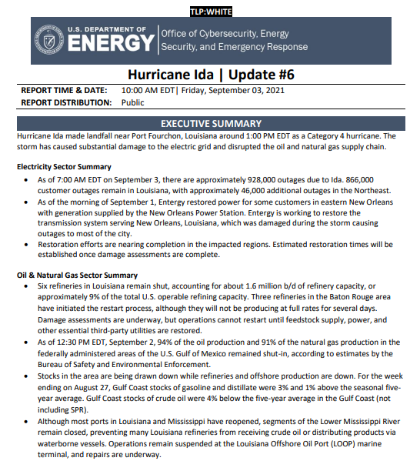
DOE EAGLE-I | Environment for Analysis of Geo-Located Energy Information (EAGLE-I) is DOE’s interactive geographic information system that allows users to view and map the nation’s energy infrastructure and obtain near real-time informational updates concerning the electric, oil, and natural gas sectors within one visualization platform. The EAGLE-I system includes a mapper, various reports, custom alerts, community features, programmatic data access, and a host of other user-focused features and is compatible for mobile-based browsers. This tool automatically gathers electrical grid service status data from company websites every 15 minutes and organizes it into an easy-to-read picture of electrical service status nationwide. EAGLE-I covers more than 90% of all U.S. electricity customers. Accounts and access are restricted to federal agencies, federal agency support contractors, and state Emergency Energy Assurance Coordinators.  To request an account, access the system at https://eagle-i.doe.gov/ and click “New User? Sign Up.”  Dashboard: Once logged in, the home page has three dashboards: electricity, oil, and natural gas. The electricity dashboard shows overall U.S. customer outages as well as states and utilities with the highest numbers of outages. The oil dashboard shows refinery statuses and alerts to operational issues. The natural gas dashboard has pipeline-related critical notices and nominations at various meter stations across the U.S.  Mapper: The National Outage Map pulls dynamic datasets to provide a near real-time visual of the electric grid. The map shows the states color-coded corresponding to the total customers with outages or the percentage of total customers with outages. Additional layers include energy infrastructure (e.g., power plants, pipelines, substations, and transmission lines) and real-time weather hazards such as earthquakes, hurricanes, and wildfires.  Reports: More granular data can be pulled from the reports, including current customer outages by utility, county, state, or outages looking back over time. The user can access reports to see notices or status alerts on electric Independent System Operators (ISOs) and Regional Transmission Operators (RTOs), natural gas pipelines, refineries, ports, and gas stations.
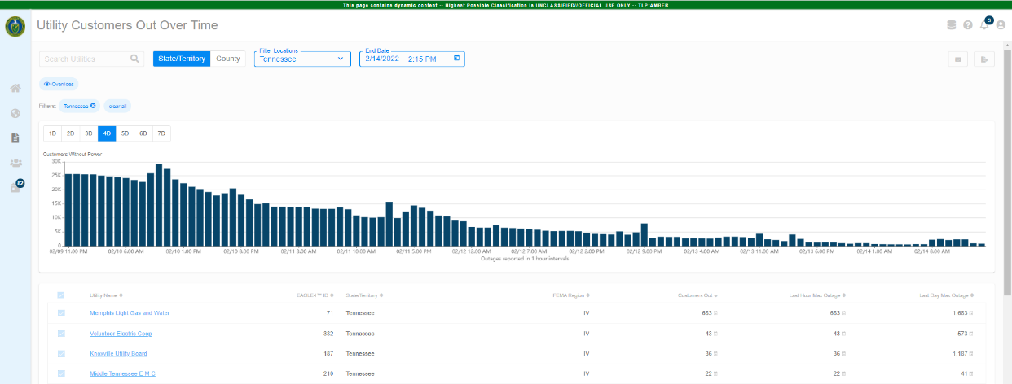
During an emergency (like an inclement weather event), SLTT officials can track outages within their area over time and see how many customers are without power by utility every 15 minutes using the Utility Customers Out Over Time Report (see screenshot below). SLTT officials can customize their dashboard to check for issues daily even without an active emergency; including power outages within their state, relevant refinery shutdowns, and key natural gas pipeline nominations and critical notices. Users can select their state as default in preferences, which will adjust the dashboard.
DOE Estimated Customer Power Outages | DOE’s Argonne National Laboratory (ANL) produces preliminary estimates of the potential peak number of electric customer outages based on storm forecasts from the National Hurricane Center. ANL has a predictive outage model that estimates power outages within the projected 72-hour wind-swath for hurricanes. These TLP:AMBER level reports are issued by CESER via email to Energy Emergency Assurance Coordinators in potentially affected states for their situational awareness in advance of a storm.
EIA U.S. Energy Atlas | The EIA U.S. Energy Atlas shows detailed energy infrastructure in an interactive web map application. The Energy Atlas has the ability to combine EIA’s data with information from other sources to create a custom geospatial analysis that features 84 map layers, 60 of which are based on EIA surveys including locations of power plants, pipelines, refineries, terminals, and other energy facilities. Energy Atlas also uses Homeland Infrastructure Foundation-Level Data (HIFLD), which is public domain information used to support community preparedness, resiliency, and research. Users can download entire datasets or filtered subsets in a variety of data formats, including shapefile, KML file, geodatabase file, and spreadsheet.
 | These customizable maps help users see what key energy infrastructure elements could be affected by natural disasters such as hurricanes, tropical storms, or wildfires. For example, a state user could overlay wildfire perimeters and electricity infrastructure to see if a fire may threaten transmission lines, substations, or power plants.
EIA Hourly Electric Grid Monitor | The Grid Monitor displays hourly data on the U.S. electricity grid by balancing authority, including hourly electricity generation by energy source, interchanges, and day-ahead demand forecasts. The grid monitor allows users to generate custom dashboards they can save and share. Yesterday’s net generation by energy source and tomorrow’s demand forecasts are available by 10:00 a.m. ET each day.
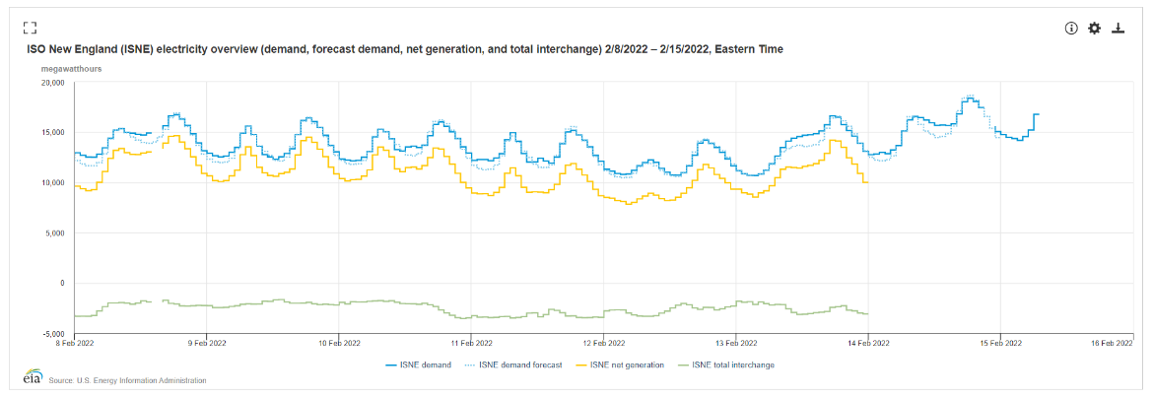
During extreme temperature events, an SLTT official can check their balancing authority to see how high demand is forecasted to be for the next day in comparison with historic demand, generation, and interchange to anticipate if there may be a risk for an electricity shortfall. The Grid Monitor could also be used to check a balancing authority for increased gas-to-oil switching by checking the level of petroleum generation over the past week on the “Electricity generation by energy source graph.”
EIA Weekly Petroleum Status Report | The Weekly Petroleum Status Report provides a weekly snapshot of supply, demand, and inventory data for petroleum fuels such as crude oil, motor gasoline, distillate fuel oil, jet fuel, residual fuel oil, propane, and other petroleum products. The data are compiled from responses from more than 1,000 supply chain participants and aggregated at a national and regional level (for each of the five Petroleum Administration for Defense Districts, or PADDs). The data are publicly released at 10:30 a.m. ET every Wednesday with values from the previous week.
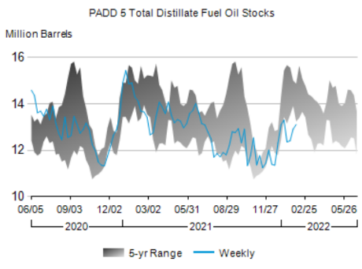
SLTT officials can check distillate fuel oil stocks in their PADD in advance of a winter storm. Weekly data can be compared to historical seasonal averages for context (i.e., whether data trends are in line with previous years or outside of normal parameters).
EIA Winter Heating Fuels | EIA has a special dashboard during the winter that provides data and graphics on winter heating fuels. Data on fuel storage for various heating fuels (propane, heating oil, and natural gas) are updated every Wednesday with values from the previous week. The Winter Propane Market Update is a propane-specific presentation that displays sub-PADD inventories of propane and even select state inventories in key areas of the Midwest. Pricing analysis for the main U.S. and Canadian hubs helps describe where propane is incentivized to move. This propane presentation is updated late in the afternoon on Wednesdays during heating season. The Winter Heating Fuels page links to the Winter Fuels Outlook prepared by EIA each October, which forecasts fuel consumption and expenditures based on weather forecasts from the National Oceanic and Atmospheric Administration (NOAA). The dashboard also has near-term and longer-term temperature outlooks from NOAA for the United States.
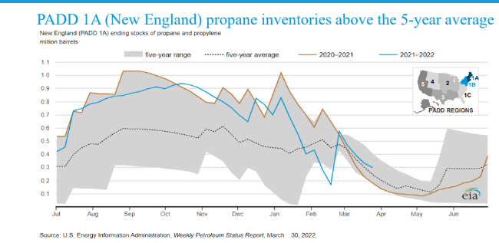
An SLTT official could use the Winter Propane Market Update to check more granular groupings of state propane stocks. Seeing stock levels below average or below the five-year range may suggest that the SLTT official should begin outreach to industry; this update could be used as support for waivers, as necessary.
EIA SHOPP | EIA’s State Heating Oil and Propane Program (SHOPP) is a cooperative data collection effort between EIA and the State Energy Offices for weekly residential heating oil and propane prices at a state level during winter months. Weekly status reports are provided to the states that summarize weekly heating fuel activity, EIA’s expectations based on trends, and the latest news on industry-related events. Direct retailer contact by states often provides early insight into market issues. States can monitor prices to identify trends that may be indicative of supply disruptions or logistics constraints.
 | SLTT officials can use SHOPP heating fuel prices as indicators of industry trends. For example, sharp week-to-week increases in propane prices may indicate a logistics constraint getting propane into the state. Because the state is already engaged in industry outreach to collect pricing data for this program, these conversations should be used as an opportunity to ask industry about operational issues and market conditions.
EIA Natural Gas Storage Dashboard | EIA’s Natural Gas Storage Dashboard shows natural gas storage activity in several regions of the Lower 48 states and key market fundamentals that affect underground natural gas storage activity. Other metrics include temperature visualizations, estimated natural gas consumption by sector, exports, natural gas prices, and the difference between current Lower 48 inventories and the most recent five-year averages. The commentary section of the dashboard provides analysis of recent natural gas storage-related market conditions. These articles analyze aspects of the natural gas market such as potential drivers of change in storage inventories, occasional details on EIA-derived storage statistics, and trends in natural gas storage infrastructure. This dashboard is updated in the mid-afternoon on Thursdays.
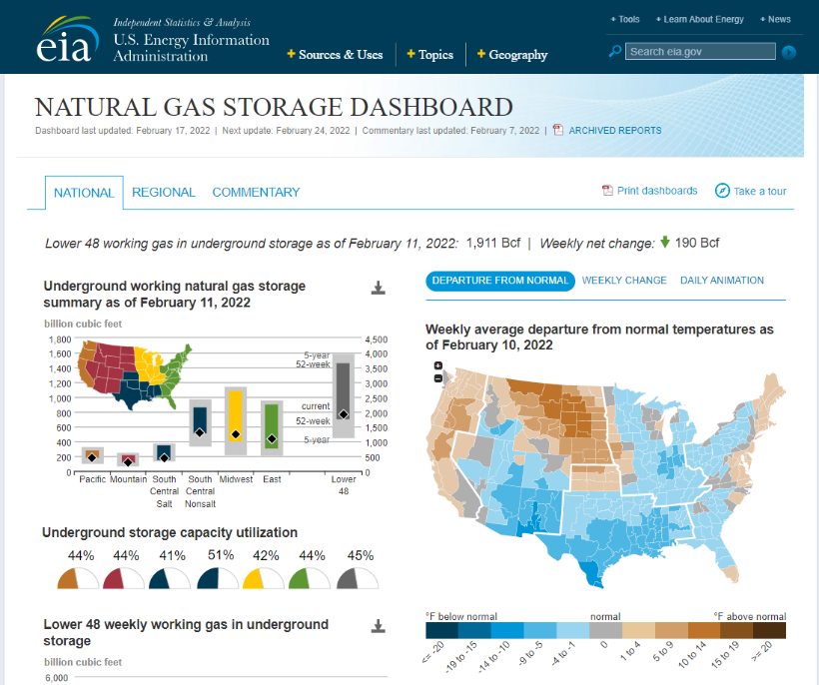
An SLTT official may utilize the Natural Gas Storage Dashboard to quickly see where natural gas storage stands in their region in comparison to the five-year average and range and use this information as a potential indicator of supply issues or to predict price spikes when extreme temperatures occur.

EIA Daily Prices | EIA’s Daily Prices shows daily wholesale and retail prices for various energy commodities, including spot prices and select futures prices at national or regional levels. These prices are sourced from third parties Refinitiv, AAA, CME Group, and SNL Energy. Prices are updated every weekday (excluding federal holidays), typically between 7:30 a.m. and 8:30 a.m. ET for yesterday’s settlement.
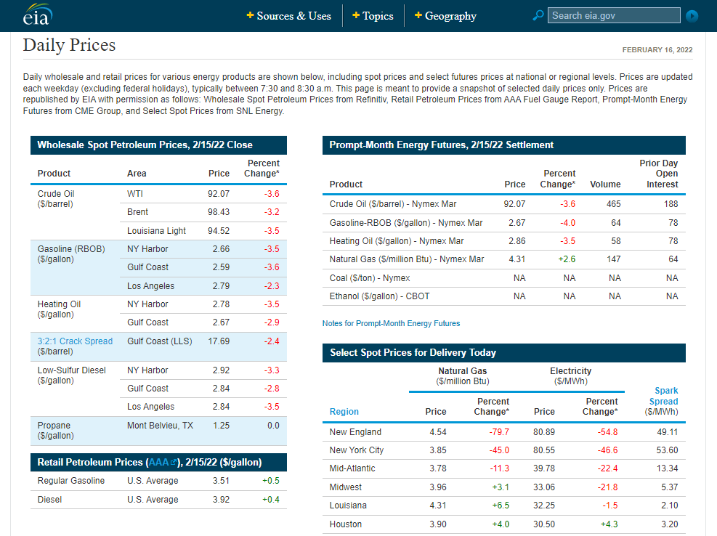
Prices can be used as indicators for supply or logistics issues. With regular tracking, price spikes can be quickly identified. Additionally, price comparison across different regions may suggest constraints that are impacting the higher-priced regions.

U.S. Coast Guard Homeport | Homeport is the U.S. Coast Guard’s portal for the Maritime Community, where port status updates are posted. The user can navigate to any port sector of interest and see a table of statuses for every port. A visual of green for open, yellow for restricted, and red for closed accompanies the port status for a quick visual, and comments may add context. These statuses are updated typically in real time by the captain of the port. Marine Safety Information Bulletins (MSIBs) are typically posted with every status change to give additional context on the event causing a port closure and may include insight on the restrictions in place at the port (such as vessel draft restrictions). In some cases, the MSIBs are updated more quickly than the status table on each port sector’s homepage, so it is worth checking that list if there is not a recent status update in the table. Port statuses are also being pulled into Eagle-I in the Port Status Report.
 | During a hurricane, many ports will close to all inbound and outbound traffic in advance of the storm’s arrival. Homeport can be used to track which ports are impacted, find information about damage assessment, and track restoration of port operations.
NPMS PIMMA | The National Pipeline Mapping System (NPMS) Pipeline Information Management and Mapping Application (PIMMA) is a web-based mapping application designed to assist federal, state, and local government officials and pipeline operators with mapping pipelines, liquified natural gas plants, and breakout tanks. It does not contain distribution or gas-gathering pipelines. State and local government officials may request access to the State and Local Government PIMMA by filling out and submitting an online application. Applicants will only be granted access to the jurisdiction in which they are employed. Within the Public Map Viewer, the user may access the NPMS data for one county at a time. Information obtained and maps produced from the Public Map Viewer are for general information only and may be redistributed as needed. In accordance with PHMSA’s security policy, the scale in which the user can zoom into NPMS data is restricted.
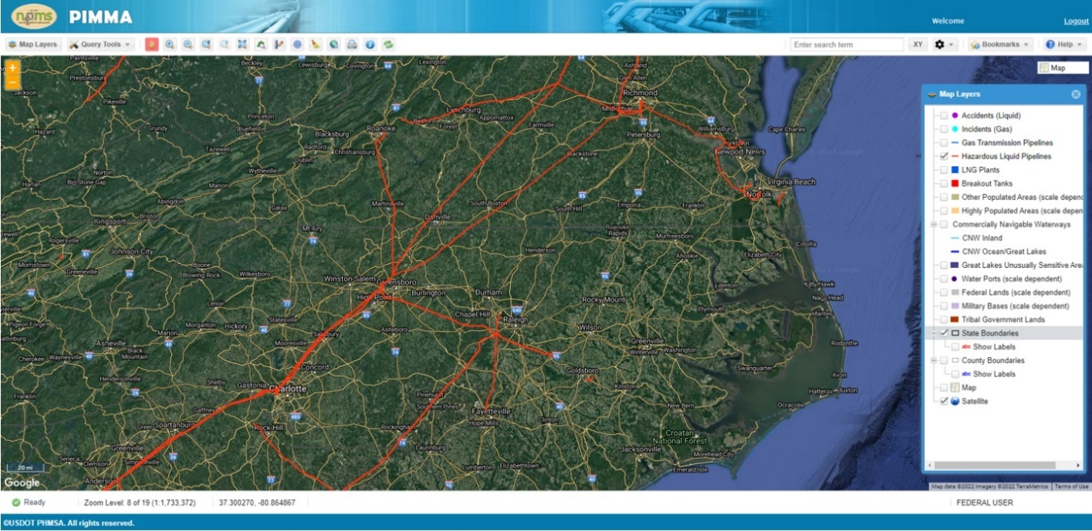
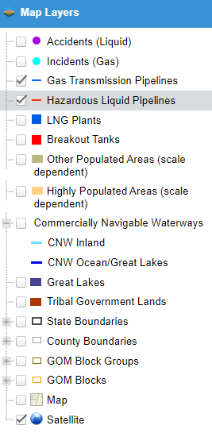
If there is an incident involving a pipeline issue, navigating to the location of the pipeline on the NPMS PIMMA system can give the user information about the pipeline, such as what products it ships and its size. In many incidents, the name of the pipeline may be initially unknown and using PIMMA can help determine what pipeline or operator is in a certain location. The system can also be used to see where pipelines travel in order to identify locations that may be disrupted by a system outage.

BSEE Activity Statistics Update | As severe weather systems move into the Gulf of Mexico and threaten oil and gas production facilities and drilling rigs, operators begin the process of shutting-in production and evacuating personnel from the offshore facilities and rigs. The Bureau of Safety and Environmental Enforcement (BSEE) Gulf Region Hurricane Response Team is activated, which monitors and reports production shut-in and evacuations that have taken place daily. These activity statistics updates are posted at 2:00 p.m. ET every day during the storm event.
 | SLTT officials can view the daily BSEE data on shut-in offshore production of crude oil and natural gas as an indicator of a crude oil and/or natural gas supply imbalance that could cause refineries to shut down or reduce production or result in potential shortfalls of natural gas into major pipeline systems.
HHS emPOWER Map | The U.S. Department of Health & Human Services (HHS) emPOWER Map is an interactive online mapping tool that provides a monthly total of Medicare beneficiary claims for electricity-dependent equipment and devices at the national, state, territory, county, and zip code levels. This can also be mapped against near real-time NOAA severe weather and other natural hazard tracking services to help identify impacted areas and estimate the number of electricity-dependent individuals who may rapidly seek assistance from first responders, hospitals, and emergency shelters.
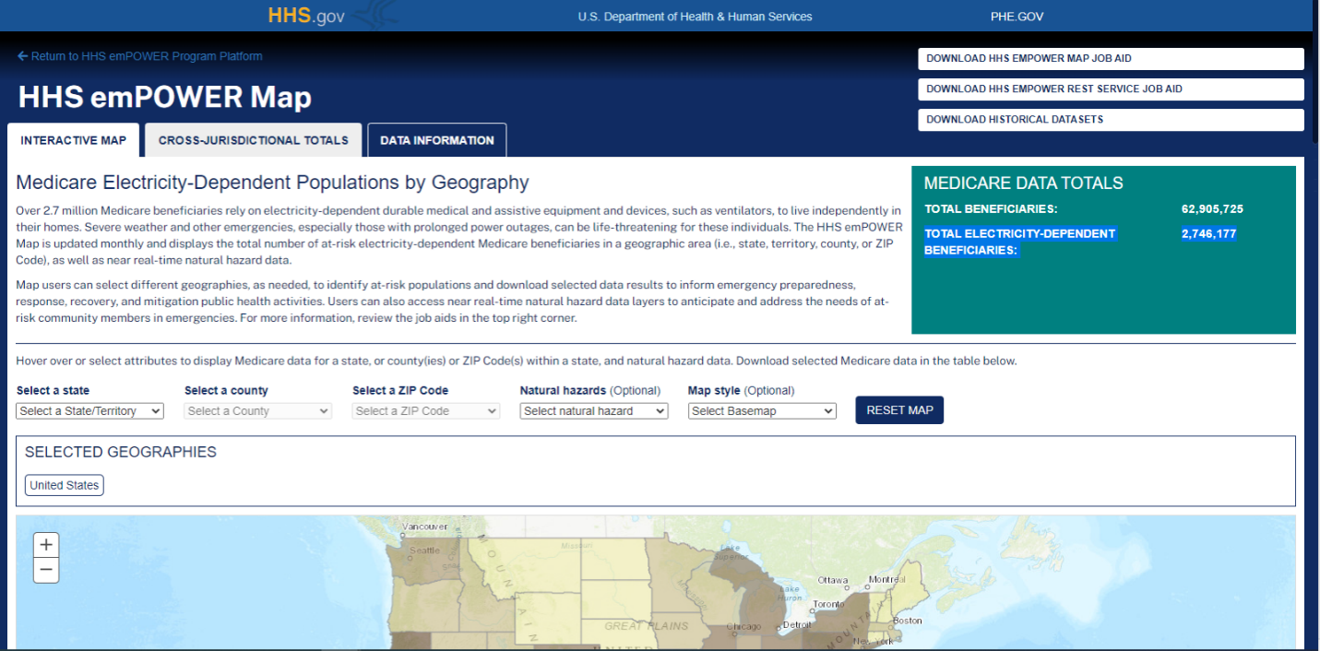
SLTT officials can use this mapping tool when working with health officials and electric utilities to help minimize health impacts of prolonged power outages due to storms and other disasters on vulnerable residents.
RTO/ISO Website | Some states’ electric grid is operated by an RTO or ISO. Every RTO/ISO has a website with information about the status of their grid and current generation and electricity demand, interchange with other grids, forecasts for the coming days, and more. These sites will also post any of the three Energy Emergency Alert (EEA) levels if the balancing authority experiences conditions requiring emergency operations.
Users in Texas, for example, can monitor the ERCOT website dashboard to see whether they are operating under normal conditions or have an emergency alert in place. ERCOT displays the current level of operating reserves and depicts available supply versus predicted demand. The supply and demand graphic can be used to assess the probability of risk to grid operations for the day.
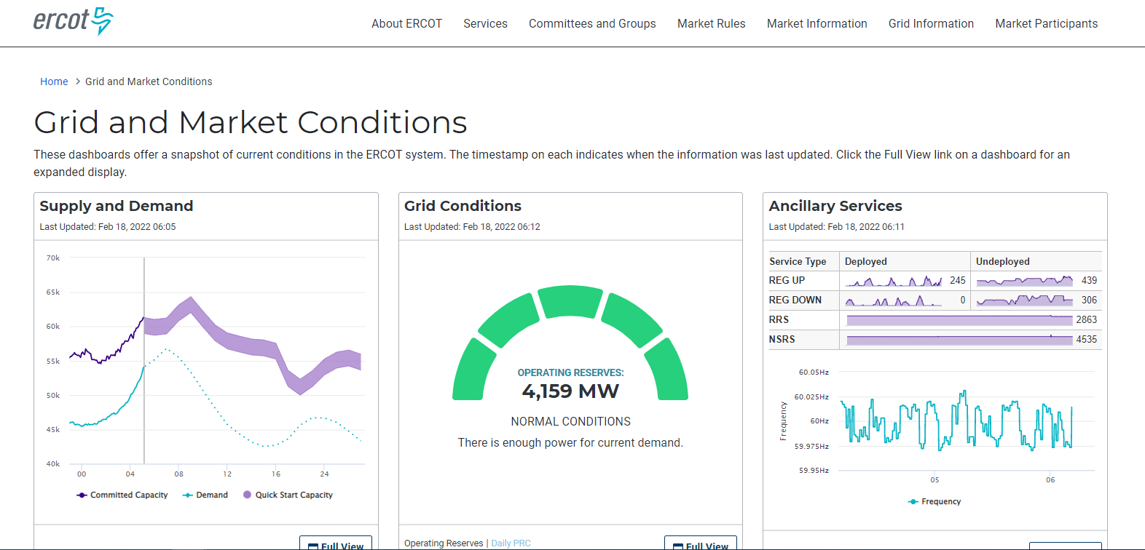
RTO/ISO Locational Marginal Pricing | Locational marginal pricing (LMP) is a means of pricing electricity at different locations (nodes) in organized wholesale markets facilitated by RTO/ISOs. LMPs differ generally among locations, because transmission and reserve constraints prevent the next-cheapest megawatt of electric energy from reaching all locations of the grid. LMP contour maps typically show the variation in pricing across the entire RTO/ISO. LMPs are updated frequently (usually every five minutes).
 | 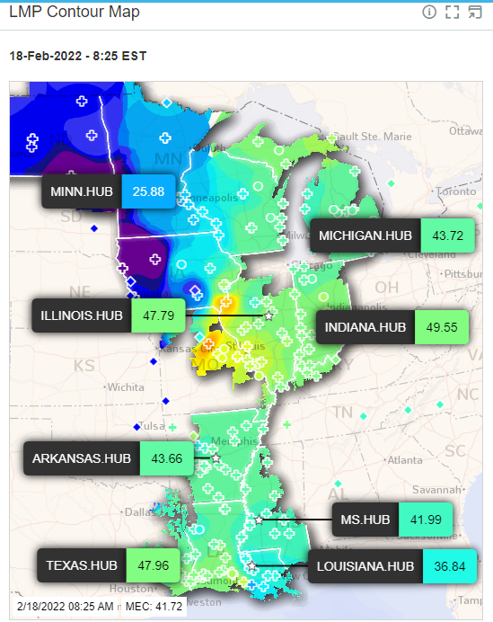 |  | SLTT officials can use an LMP contour map from their respective RTO/ISO as an indicator of operational issues within a portion of the grid. If a particular area or region has significantly higher prices than others within a particular balancing authority, this may indicate that a key power plant is offline, or a transmission connection has malfunctioned. Links to the various LMP maps are below:  ERCOT  MISO  ISO-NE  SPP  NYISO  PJM  CAISO
GasBuddy | During some liquid fuel supply chain disruption events, GasBuddy initiates their crowdsourced gasoline station tracker application. They post intermittent updates on the percentage of stations without fuel or power in each tracked state and metropolitan area via press releases on their website and on their Twitter page. Retail station information from GasBuddy provides a directional indicator of trends and does not reflect the status of all stations. Outage information may or may not always be current as the data is sourced from users, and percentages are based on the total number of stations, not volume of retail fuel.
 | SLTT officials can use GasBuddy updates on the percentage of out-of-service stations in various metropolitan areas as indicators for identifying which areas are most impacted by supply shortfalls or power outage events. It can also be useful to track how or if the percentages decline over time, indicating restoration. Unfortunately, some stations do not get their status updated when operations resume, so the data may lag actual restoration.
Media Sources | The media shares with its viewers public information concerning current energy issues by tracking energy disturbances and reporting on company-issued statements and press conferences. There are numerous media outlets with varying degrees of credibility, but some of the best to use when tracking energy-related emergencies are Reuters, Bloomberg, Platts, and OPIS.
 | For example, the media typically tracks refinery outages and reports on official refining company statements, updates from sources familiar with operations, public filings with government agencies, and witness accounts. Official company reporting provides information to stakeholders with pertinent information that is clear, reliable, verifiable, and could be acted upon for proper response during an emergency.
NOAA’s National Weather Service | The National Weather Service (NWS) provides weather, water, and climate forecasts and warnings for the United States and its territories. These services include forecasts, observations, and warnings on various types of severe weather, including thunderstorms, flash flooding, blizzards, winds, tornados, red flags, coastal flooding, fog, and more. NWS webpages and dashboards are updated daily and provide key insight to the potential impact any hazardous weather event could have on the United States. NWS also releases impact updates after events have occurred describing the event and what has transpired since its arrival.
The NWS advisory map can be checked daily to get a quick view of forecasted adverse weather warnings and advisories in any state or territory. For example, if there are extreme cold or blizzard warnings within the state, this may prompt outreach regarding propane supply and demand. If a severe wind or thunderstorm is coming through, this suggests that more frequent checks on customer power outages are warranted.
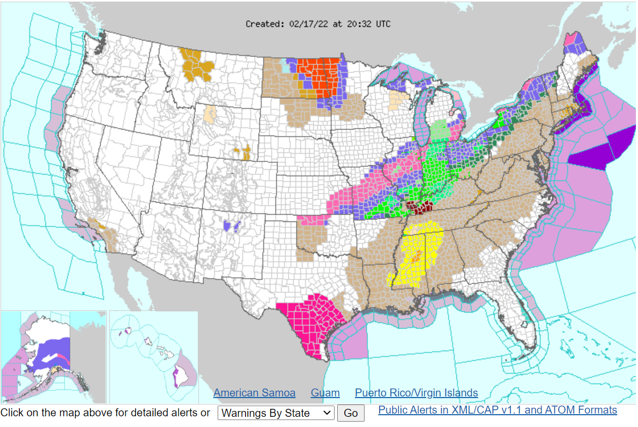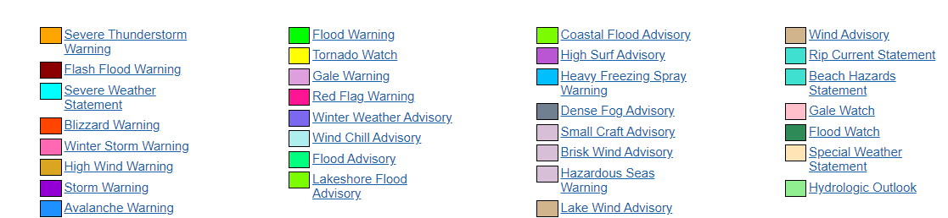
NOAA Climate Prediction Center:  6- to 10-Day Outlook | NOAA’s Climate Prediction Center (CPC) releases 6- to 10-day outlooks for the expected temperature and precipitation across the nation. Temperatures and precipitation are graded on a probability that the expected amount over the next 6 to 10 days will be “greater than normal,” “less than normal,” or “normal” when compared to the previous 30 years during the upcoming date range. Temperature and precipitation predictions are important to energy security; they are an essential component to understanding the expected impact on U.S. energy infrastructure. These reports are updated daily between 3:00 p.m. and 4:00 p.m. ET.
 | SLTT officials can use the temperature outlooks to forecast demand trends for some weather-dependent energy sources. For example, a strong probability of colder-than-normal temperatures in the upper Midwest, as shown in the screenshot below, could indicate a higher demand for propane in the winter, so SLTT officials should be conducting thorough situational awareness activities to prepare.
 | 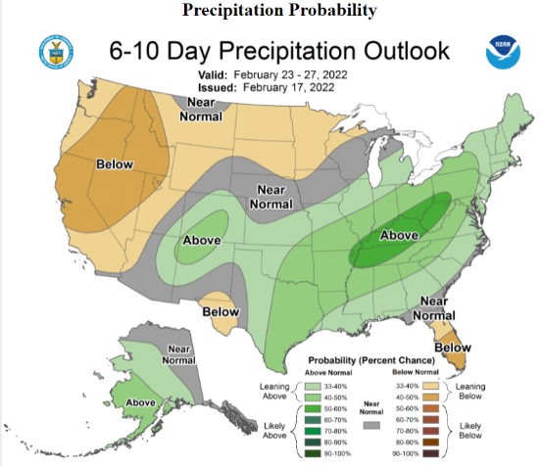 | 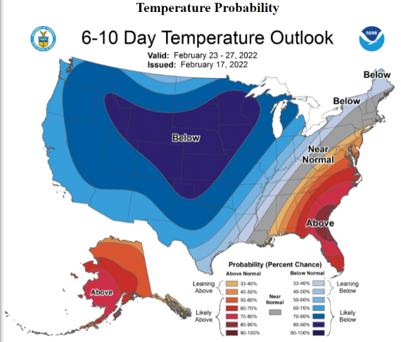
National Hurricane Center Tropical Weather Outlook | The National Hurricane Center (NHC) is responsible for issuing forecasts for all tropical cyclones in the North Atlantic and Northeast Pacific basins. The Tropical Weather Outlook discusses significant areas of disturbed weather and their potential for development during the next five days, including a categorical forecast of the probability of tropical cyclone formation during the first 48 hours and during the entire 5-day forecast period. The probabilities are expressed in terms of one of the following categories: low probability of development (0% to 30%), medium probability of development (40% to 60%), and high probability of development (70% to 100%). The Tropical Weather Outlook is issued every six hours. This source gives the official predicted storm tracks with bands of uncertainty and probabilities of wind speeds and rain totals for tropical storms and hurricanes.
SLTT officials can use the Tropical Weather Outlook to track tropical weather as soon as there is any probability of formation. They can typically begin outreach and preparedness activities several days before the area will be affected by the storm. This is the best source to monitor official storm tracks.
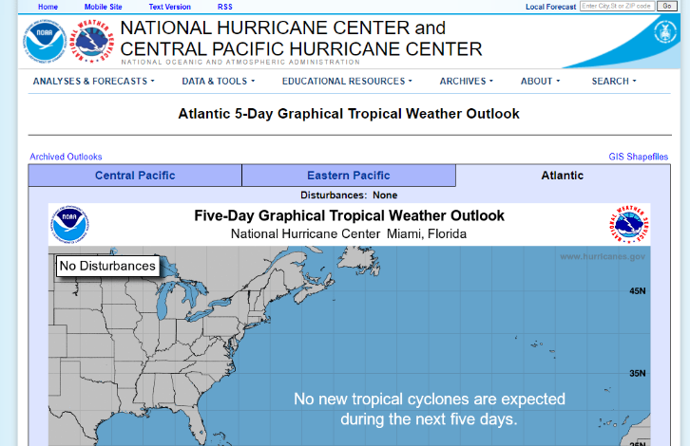
NASA and USDA’s Fire Information Resource Management System | The Fire Information for Resource Management System (FIRMS) was developed by the National Aeronautics and Space Administration (NASA) and the U.S. Department of Agriculture (USDA) to provide near real-time active fire location tools and data for users to visualize and monitor the location, extent, intensity, and impacts of wildfire activity using low-latency satellite imagery. Additional geospatial data and information from various agencies are also integrated to provide context for current or recent wildfire activity.
An SLTT official can use this mapping tool to see what wildfires are active in their area within the last 24 hours and locate specific fires that are making media headlines. Data like acreage, perimeters, active burn satellite imagery can be layered on the map for a detailed picture of a particular fire.
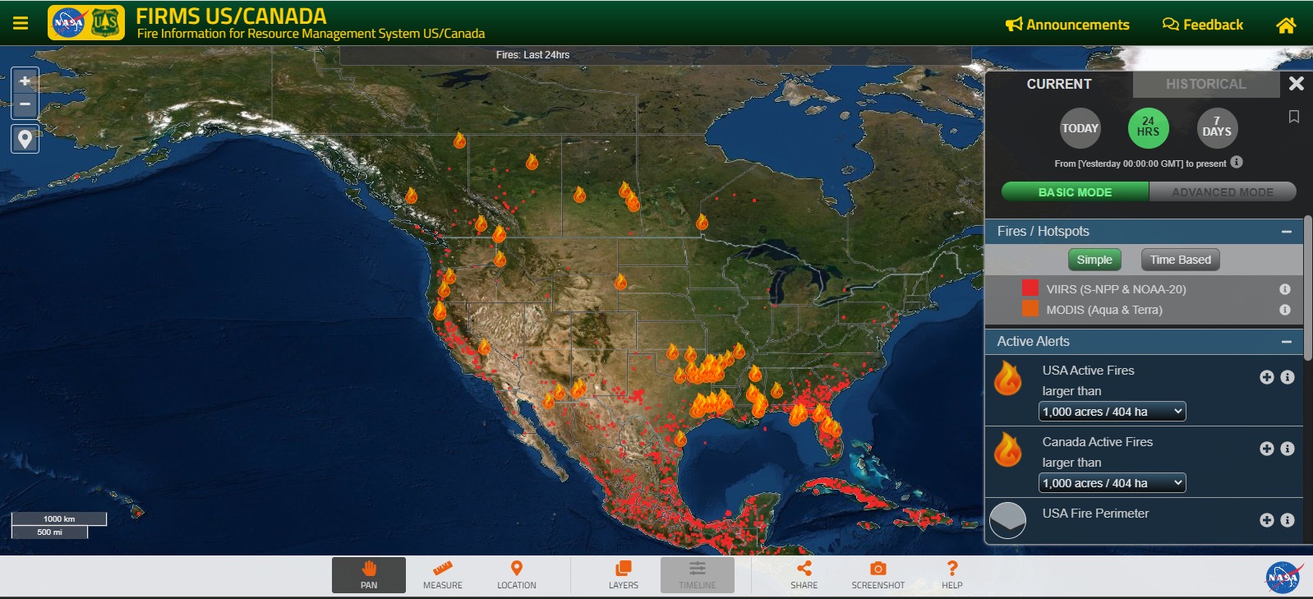
NOAA River Observations and Outlook | NOAA releases river level statuses to monitor rising and falling levels of water throughout the year. Daily water levels are categorized by their potential to flood the surrounding area ranked from “low water threshold” to “major flooding” and are mapped with colored points where they are located throughout the country. These NOAA data are updated daily.
 | River flooding may impact petroleum product barges and vessels. This type of supply chain is used in the Central Region due to its limited access to coastal areas or major pipelines.

Appendix B: Information-Sharing Contact List
The template identifies the types of organizations that could be listed as contacts and can be customized and expanded as needed.

Organization | Point of Contact | Email | Phone Number(s) | Notes
Industry
State or regional petroleum distribution association |  |  |  | Coordinate with to understand distribution limitations and waiver requests
State or regional propane association |  |  |  | Coordinate with to understand distribution limitations and waiver requests
State or regional trucking association |  |  |  | Coordinate with to understand distribution limitations and waiver requests
Major utilities |  |  |  | Coordinate with to understand restoration timelines
Key pipeline company |  |  |  | Coordinate with to understand restoration timelines
Refiner |  |  |  | Coordinate with to understand issues, particularly in regions that rely on supply from fewer refineries
Terminal owner |  |  |  | Communicate with to learn about issues with loading supply and storage levels
Distributor for state fuel contract |  |  |  | Communicate with to ensure state facilities have fuel
State Government
Office of the Governor |  |  |  | Contact for executive orders and state emergency declarations or proclamations
State Public Information Officer or Crisis Comms |  |  |  | Coordinate to assist with accuracy of energy messaging. Ensure messaging strategy addresses communities experiencing communications barriers
State Energy Office
Public Utility Commission
EEAC contact for the state
State emergency management |  |  |  | Coordinate resource request, coordination with other ESFs and general response. Coordinate to ensure economically vulnerable communities’ needs are met
State agency with fuel waiver authority |  |  |  | May waive regulations related to reformulated gasoline, red dye diesel, Reid vapor pressure (RVP) requirements
Department of Health |  |  |  | Coordinate dept and health care facilities to mitigate impacts and identify vulnerable populations who rely on energy for basic medical needs
State transportation agency |  |  |  | Contact for questions about hours of service, intrastate regulations, and road clearing to energy infrastructure
NASEO |  |  |  | Provide best practices and regional coordination and guidance
Federal Government
DOE Emergency Operations Center (EOC) |  | doehqeoc@hq.doe.gov | 202-586-8100 | Staffed 24/7. Contact this number with questions about energy emergencies.
Energy Emergency Assurance Coordinators (EEAC) Email Distribution Lists |  | eeac-region01@listserv.netl.doe.gov  eeac-region02@listserv.netl.doe.gov  eeac-region03@listserv.netl.doe.gov  eeac-region04@listserv.netl.doe.gov  eeac-region05@listserv.netl.doe.gov  eeac-region06@listserv.netl.doe.gov  eeac-region07@listserv.netl.doe.gov  eeac-region08@listserv.netl.doe.gov  eeac-region09@listserv.netl.doe.gov  eeac-region10@listserv.netl.doe.gov |  | Share state actions and direct any questions related to federal emergency response, including federal situational awareness products during events
DOE Regional Coordinators (RCs) | Fill in the contact information for your regional coordinator here.
EPA Fuels Program |  | FuelsProgramSupport@epa.gov | 800-385-6164  (business hours) | Direct any questions related to EPA waivers and regulatory relief
EPA – Emergency Operations Center |  | eoc.epahq@epa.gov | 202-564-3850 | Staffed 24/7. Use this line for emergency events.
FEMA |  | Contact list by region: https://www.fema.gov/about/contact |  | Use for general questions about events or disaster funding.
Transportation Security Administration (TSA) |  | pipelinesecurity@dhs.gov  TSOC.ST@dhs.gov | Security Operations Center:  866-615-5150 | Direct any questions related to pipeline cybersecurity directives
DHS – Cybersecurity and Infrastructure Security Agency (CISA) |  | Regional office contact information: https://www.cisa.gov/cisa-regions |  | Use for questions about pipeline cybersecurity and cyber incidents.
DOT – Federal Motor Carrier Safety Administration (FMCSA) |  | FMCSADeclaration@dot.gov | 877-831-2250 | Direct any questions related to FMCSA emergency declarations, waivers, and regulations during a declared disaster
DOT – Pipeline and Hazardous Materials Safety Administration (PHMSA) |  | Regional offices and contacts: https://www.phmsa.dot.gov/about-phmsa/offices |  | Use for questions about pipeline leaks and physical pipeline safety.
Internal Revenue Service (IRS) |  |  | 866-699-4096  (business hours) | Use this excise tax hotline for questions about IRS waivers and regulatory relief

Appendix C: Threats and Potential Impacts to Energy
Hazard | Power | Liquid Fuels |  | Natural Gas
Cyber Incident | Informational technology and operational technology systems can be impacted; this can include company data, payment and scheduling systems, sensors, and control systems.
Drought | Reduced hydroelectric generation due to low water levels.  Reduced efficiency at thermoelectric generation facilities if there are constraints on steam or cooling. | Impacts to biofuel feedstocks from low moisture in soil.  Low water levels can prevent barge traffic on inland waterways.  May limit drilling and refineries operations if alternative water supply is not available. |  | May limit drilling activity if alternative water supply is not available.
Dam Failure | Damage to downstream infrastructure due to flooding and debris.
 | Hydroelectric power generation may be disrupted, which may also reduce black start capabilities. | Unearthing and rupturing of pipelines. |  | Unearthing and rupturing of pipelines.
Earthquake | Damage to infrastructure.
 | Examples: power generation facilities, transmission poles, etc. | Examples: pipeline rupture, refineries, well sites, pumping stations. |  | Examples: pipeline rupture, processing plants, well sites, compressor stations.
Equipment Malfunction | Line arcing, power surges, corrosion, or moisture on equipment can cause equipment to malfunction or go offline. | Corrosion, material failure, excess pressure buildup, or controls malfunction can cause supply disruptions,
Extreme Heat | Increased demand for cooling. Depending on the available capacity, this can cause ISOs to operate below reserve margins.  Increased risks of wildfires from power lines. | Can reduce efficiency at refineries.
Flood | Damage to equipment exposed to water and debris.
 | Examples: power generation equipment, control center buildings, transmission lines. | Examples: refinery process units, tanks underground pipelines. | Examples: processing plant units, LNG export facilities, underground pipelines.
Landslide | Damage to nearby infrastructure due to debris or foundation impacts.
Man-made Damage | Deliberate physical attacks on or takeovers of infrastructure. Human error can cause facilities to run outside of designed parameters.
 | Transmission lines may be impacted by individuals hitting power poles, cutting trees down, or striking underground wires. | Third-party strikes of pipelines can rupture lines.
Pandemic | Shifts in demand and reduced worker availability.
Tropical Cyclone | Damage to infrastructure from high winds, debris, and flooding.
Tropical Cyclone | Damage to infrastructure from high winds, debris, and flooding.
 | Examples: power generation facilities, transmission poles, etc. | Examples: pipeline pumps, tanks. |  | Examples: pipeline pumps, tanks.
Production facilities and refineries may shut down ahead of storm for personnel safety.
Shoaling in ports can prevent ship and barge traffic to terminals.
Thunderstorm and Lightning | Blown transformers and downed trees may impact power lines. | Power outages may impact refinery, terminal, or pumping operations. |  | Power outages may impact select electric compressor operations.
Tornado | High winds can cause damage to power lines and power generation facilities. | High winds can cause damage to refineries, terminals, and other above-ground facilities. |  | High winds can cause damage to processing plants, compressor stations, metering and regulating stations, and other above-ground facilities.
Wildfire | Damage to power lines and power generation facilities.  Utilities may shut off power to prevent wildfires (e.g., high temperatures and high winds). | Combustible material if exposed, primarily impacting above-ground infrastructure.
Winter Storm and Extreme Cold | Freezing in cooling towers preventing electric generation.  Rail freezing impacting feedstock to power generation (e.g., coal).  Increased demand for heating can add strain to available capacity, causing RTOs/ISOs to operate below reserve margins. | Freezing for non-weatherized equipment, including frozen product within piping system, malfunctioning flow control equipment, flaring, and production shut-ins.  Increased back-up generator demand. |  | Freezing may impact non-weatherized equipment, which can cause production shut-ins.  Increased demand for heating can strain capacity.

Appendix D: Supply Chain Diagrams
The diagrams below provide an overview of the various nodes and transport modes in the supply chain for each energy type.
- Most electricity is produced at large-scale power plants and transported to end users via transmission and distribution lines with substations stepping the voltage up or down. In recent years, however, electricity is increasingly generated at distribution-level generators and at consumer sites with behind-the-meter devices, in part due to growing small-scale renewable generation. In both utility-scale generation and distributed generation, energy storage may be connected to the electric grid, storing electricity when there is a supply surplus and later discharging it onto the grid as needed.
- Petroleum products and propane are derived from crude oil. Crude oil is produced from underground reservoirs. Once transported to refineries, crude oil is refined into finished petroleum products, such as gasoline, diesel, jet fuel, residual fuel oil, and propane. Fuels are delivered to bulk terminals by pipeline, marine vessel, or ground transportation such as rail or road and stored in large tanks before being loaded onto distribution trucks (with appropriate blending of ethanol and additives for gasoline) for delivery to retail stations, heating oil distributor storage depots, and other end users. Most U.S. propane is produced from natural gas liquids, or NGLs, which are liquid components recovered during natural gas processing. NGLs are separated into purity products, including propane, ethane, and butane, at fractionation facilities. After fractionation, propane (also called liquefied petroleum gas or LPG) is compressed and stored as a liquid and moved by pipeline, truck, rail, or barge to bulk propane terminals or directly to distributor storage depots. From distributor sites, the propane is transported by smaller trucks, known as bobtail trucks, to end users like residential and commercial customers.
- Natural gas is produced either on its own or as associated gas in crude oil production. Natural gas is then separated from NGLs in natural gas processing plants. Gas is typically transported by transmission lines to city gate meters where gas then moves onto local distribution companies’ distribution systems, which deliver gas to power plants and other end-use customers. Gas can be stored at various levels of the supply chain in underground storage caverns for use during high-demand times. It also can be converted into a liquid form, called liquified natural gas or LNG, which can be transported via marine vessels and either imported into the transmission system or its excess supply exported.

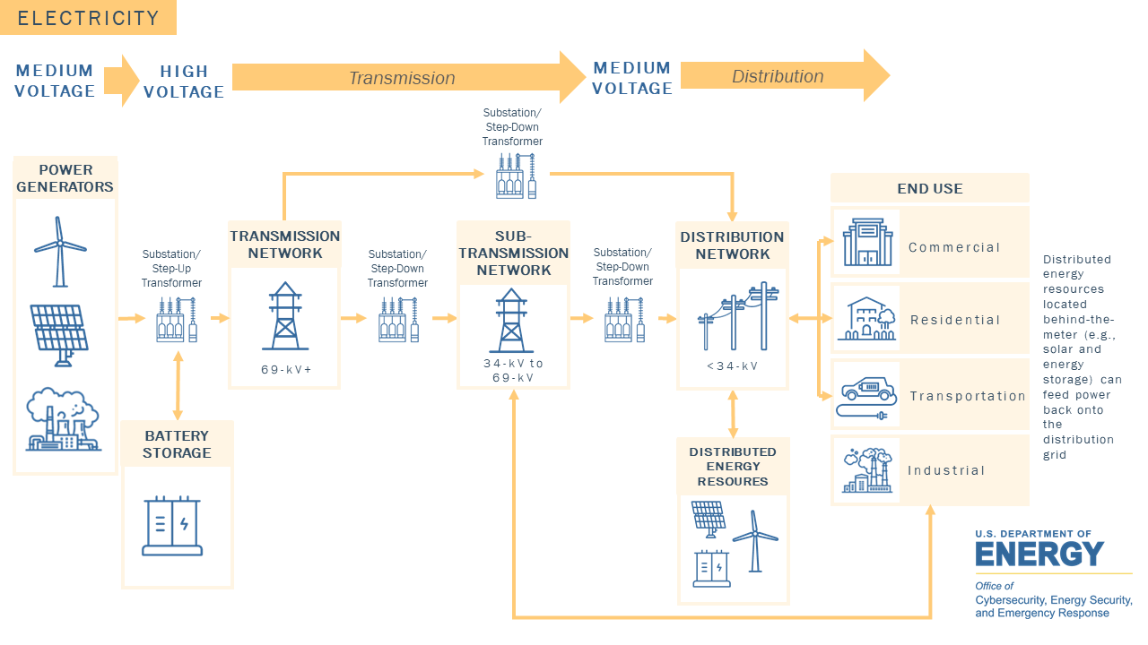

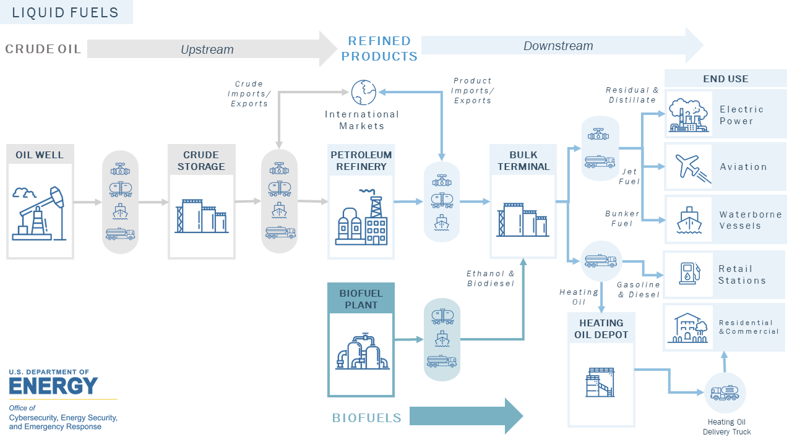

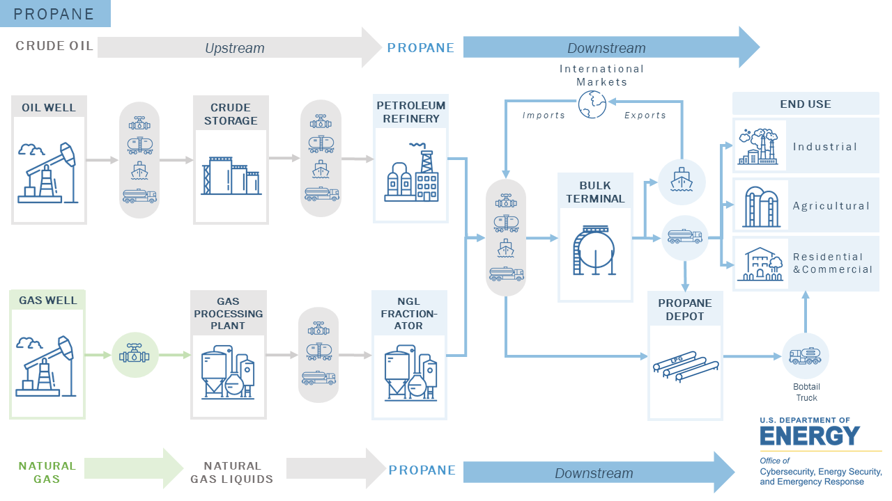

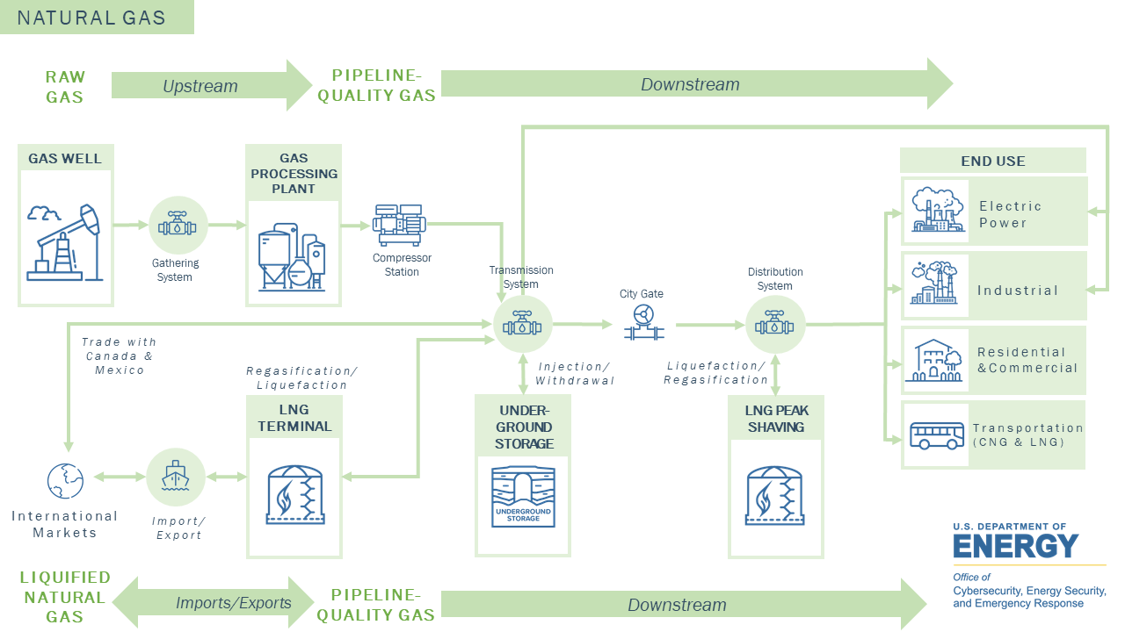

Appendix E: Interdependency Diagrams
Interdependencies and connections exisit between critical infrastructure sectors. Identifying and understanding interdependencies (two-way) or dependencies (one-way) between infrastructure assets and sectors is important for assessing risks and vulnerabilities and energy security and resilience planning.
The Department of Homeland Security (DHS) has defined 16 critical infrastructure sectors, including energy. All of the the other critical infrastructure sectors depend on power and/or fuel to operate. A disruption or loss of the services provided by the energy sector can directly affect the secuirty and resilience within and across numerous sectors. The energy sector also depends on other sectors to help provide its services. There are also interdependencies within the energy sector itself. A comprehensive understanding of such interdependencies enables the sector to mitigate potential vulnerabilities and helps ensure that the nation’s economy continues to deliver goods and services during extraordinary events.
The diagrams that follow show key dependencies and interdependencies between the three energy types and FEMA community lifelines.

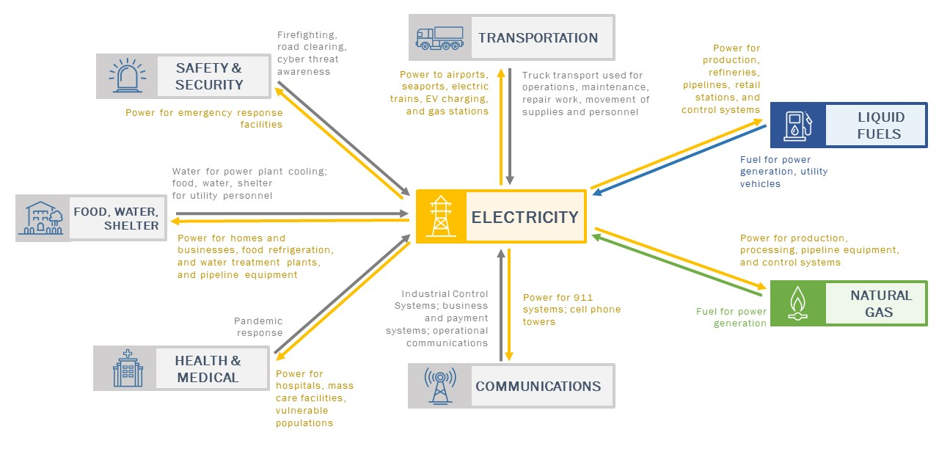
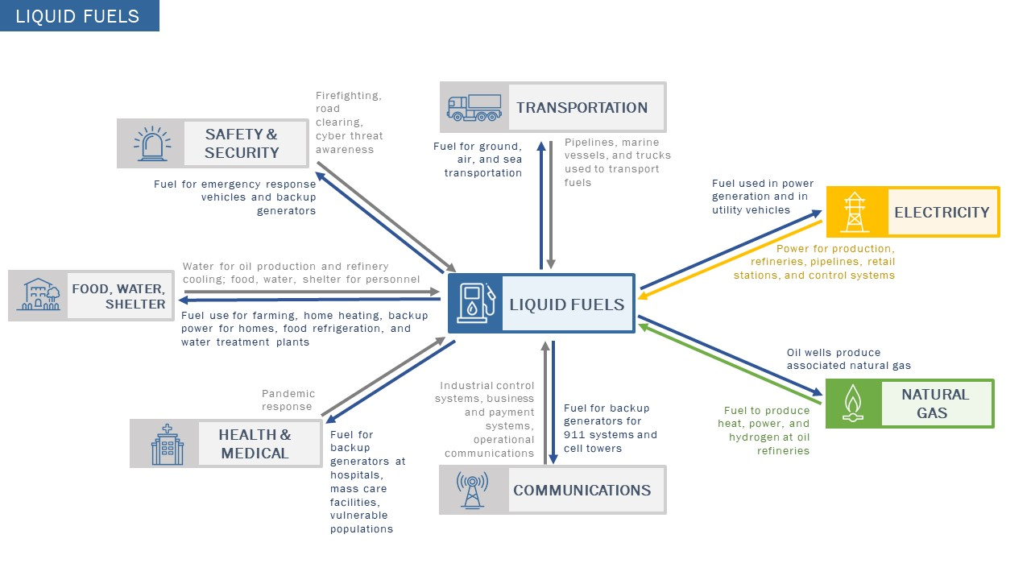

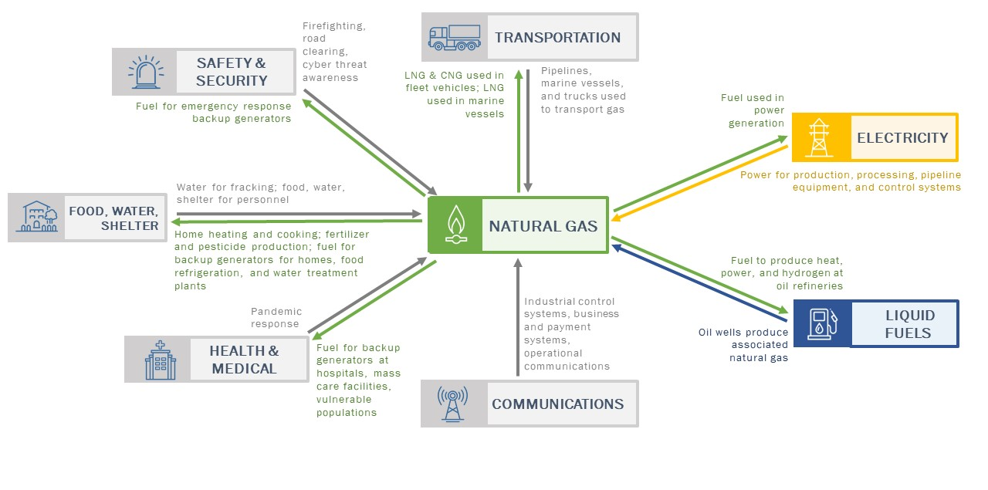

Appendix F: Considerations for Territories and Remote Areas
U.S. Territories, which are geographical isolated from the mainland U.S., have additional factors to consider, and challenges to confront, during energy emergency response. The table below describes some of these considerations.
Sector | Considerations
Electricity | Territories have a single power utility. This limits mutual aid response, often resulting in extended response times.  The territories’ self-sustained power grids provide limited redundancy, and electricity cannot be imported from another ISO during supply shortages.  Distance from the mainland can lead to delays in receiving replacement parts, backup generators, and other response equipment. Reliance on ports can present challenges in getting equipment or alternative materials and receiving mutual aid. Reliance on ports also make territories particularly vulnerable to events that cause port closures or disruptions.
Liquid Fuels | Reliance on ports for fuel imports make territories particularly vulnerable to events that cause port closures or disruptions.  Territories are largely dependent on truck transport of fuel to end users, making them particularly vulnerable to events that damage or disrupt roads.
Natural Gas | Reliance on ports for natural gas imports make territories particularly vulnerable to events that cause port closures or disruptions.

Puerto Rico Only: The Maritime Marine Act of 1920 (The Jones Act)
The Jones Act requires that the only vessels that can transport goods between two U.S. ports must be U.S. flagged, built, owned, and crewed. This requirement may limit or delay the delivery of fuel or other energy-related shipments during emergencies.

Among the U.S. territories, only Puerto Rico is subject to Jones Act requirements. The U.S. Virgin Islands, American Samoa, and the Northern Mariana Islands are exempt from the Jones Act, and thus foreign-flag ships can transport cargo between these islands and other U.S. points.

TO DO: Consider additional factors affecting your territory and document them below.
___________________________________________________________________________
___________________________________________________________________________
___________________________________________________________________________
___________________________________________________________________________
___________________________________________________________________________

Appendix G: Considerations for Vulnerable Populations
Every community’s ability to prepare for, mitigate, and respond to emergency events is unique, and community members who are medically, economically, or socially vulnerable may experience more intense event impacts than others. Past events, such as Hurricane Katrina, demonstrate the importance of identifying vulnerable populations, anticipating their particular needs, and prioritizing or otherwise targeting aid to those groups during an event.
The following table provides examples of vulnerable communities, as well as specific impacts that they may experience from energy disruptions. State Energy Offices are encouraged to review this list and modify it to reflect the specific communities and potential event impacts within their own state.

TO DO:
Review the table below, which provides examples of types of vulnerable communities. Using the column on the far right, document information about the specific vulnerable communities in your community, including facility names, general locations, and particular energy considerations for those communities. Points of contact for each community should be documented in Appendix B.

Examples of Vulnerable Communities | Parties Impacted by Energy Disruptions | Examples of Energy Emergency Impacts | State-Specific Vulnerable Communities and Potential Impacts of Energy Disruption
Medically Vulnerable | Those who rely on powered medical equipment, with or without batteries | Equipment (e.g., ventilator, respirator, oxygen equipment, home dialysis equipment) does not work or cannot be recharged during power outage. | _____________________________________  _____________________________________
 | Those who require refrigerated medication | Medication may be ruined during power outage. | _____________________________________
 | The very young and the elderly | Can be particularly susceptible to extreme temperatures that may be experienced during a power outage or heating fuel shortage. | _____________________________________  _____________________________________
Economically Vulnerable | Low-income communities | May not be able to afford heating fuel or transportation fuel during shortages, when prices tend to increase. May be able to use power during high-demand periods but may receive bills that are higher than anticipated in subsequent months. Unlikely to own a backup generator. | _____________________________________  _____________________________________  _____________________________________  _____________________________________
Populations Experiencing Communication Barriers | Non-English-speaking communities | May not understand English-only communications from utilities and government agencies about event impacts, safety messaging, estimated restoration times, calls for conservation, or other messages. | _____________________________________  _____________________________________
 | Those who lack access to or familiarity with the internet or computers | May not be able to access websites or social media posts with safety messaging, estimated times of restoration or other real-time communications. | _____________________________________  _____________________________________
 | Those with vision or hearing impairment | May require information to be presented through assistive technology; for example, inclusion of captions or a sign language interpreter. | _____________________________________  _____________________________________

Appendix H: Acronyms
The table below provides a list of most acronyms provided in this report. For additional information about terms used in the report, please utilize EIA’s glossary.
Acronym/Term | Description
ANL | Argonne National Laboratory
CESER | Office of Cybersecurity, Energy Security, and Emergency Response
CPC | Climate Prediction Center
DOE | U.S. Department of Energy
EAGLE-I | Environment for Analysis of Geo-Located Energy Information
EEA | Energy Emergency Alert
EIA | Energy Information Administration
EOC | Emergency Operations Center
ERC | Emergency Response Center
ESF | Emergency Support Function
ETR | Estimated time of restoration
FEMA | Federal Emergency Management Agency
FIRMS | Fire Information for Resource Management System
HIFLD | Homeland Infrastructure Foundation-Level Data
ISO | Independent System Operator
LDC | Local distribution company
LMP | Locational marginal pricing
MSIB | Marine Safety Information Bulletins
MW | Megawatt
NASA | National Aeronautics and Space Administration
NASEO | National Association of State Energy Officials
NHC | National Hurricane Center
NOAA | National Oceanic and Atmospheric Administration
NPMS | National Pipeline Mapping System
NWS | National Weather Service
OFO | Operational Flow Order
PADD | Petroleum Administration for Defense Districts
PIMMA | Pipeline Information Management and Mapping Application
RTO | Regional Transmission Operators
SEOC | State Emergency Operations Center
SHOPP | State Heating Oil and Propane Program
SLTT | State, local, tribal, and territorial
T&D | Transmission and distribution
USDA | U.S. Department of Agriculture

A cyberattack that results in a physical consequence (i.e., a no-notice power outage) would likely immediately be categorized as a Major Event. Depending on the event and scale, traditional communications may not be available. ESF-12 officials should review the state’s cyber incident response plan and know the state and utility partners’ back-up communication methods. The matrices should be updated to reflect duties for no-notice events.

